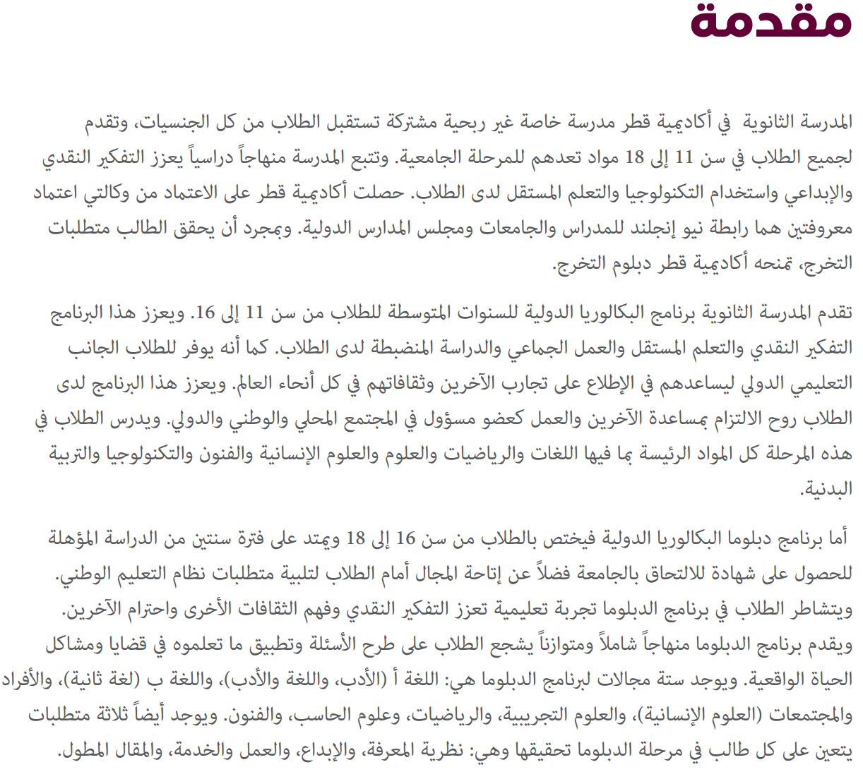
Source: http://d32gfmie1jgchg.cloudfront.net/app/media/2852

