**أعمالي اليوميّة**

1. **Match the words to the pictures. Write your answers on the provided space.**

**C:\Users\Ghina\AppData\Local\Microsoft\Windows\Temporary Internet Files\Content.IE5\CN2U5RLO\MC900383482[1].wmf**MCj03983130000[1]

__________________ __________________ __________________

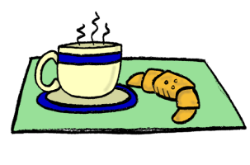j0183328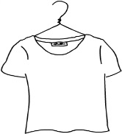

MCj04400620000[1]

__________________ __________________ __________________

MCj03975320000[1]MCj02321330000[1]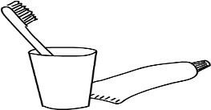

__________________ __________________ __________________

أَرْتَدِي الثِّيَاب

أنَام

|  |  |  |
| --- | --- | --- |
| أسْتَحِمُّ |  | سرِيري |
| أَذْهَبُ إِلَى المَدْرَسَة | أَفْعَلُ واجِبي | أُرتّبُ |
| أُنَظِّفُ أَسْنَانِي | أنهضُ | أَتَنَاوَلُ فَطُورِي |

1. **Now write about your daily routine:**

**Key words:**

أحيانا

بعد ذلك /ثُمَّ

الساعة السَّابعة

الساعة العَاشرة وَ النِّصْف

في الصباح

مساء

إلى /في /من المساء

الساعة الثّالِثَة

**عادة**

**الفطور/الغداء/العشاء العشاء**

**جريدة/مجلّة**

**Everyday I…**

كل يوم

**_________________________________________________________________________________________________________________________________________________________________________________________________________________________________________________________________________________________________________________________________________________________**

**_______________________________________________________________________________________________________________________________________________________________________________________________________________________________________________________________________________________________________________________________________________________________________________________________________________________________________________________________________________________________________________________________________________________________________________________________________________________________________________________________________________________________________________________________________________________________________________________**

**____________________________________________________________________________________________________________________________________________________________________________________________________________________________________________________________________________________**