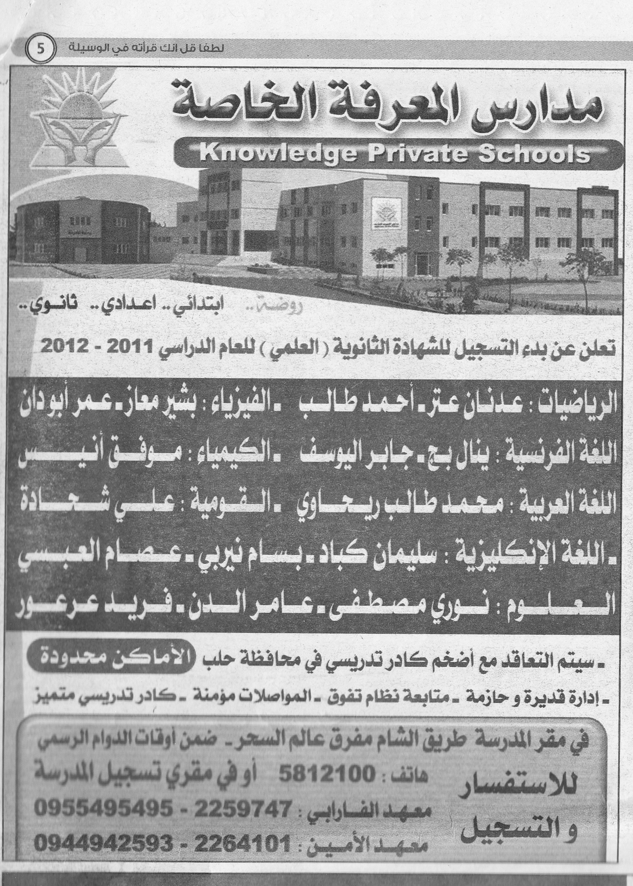

A private school (مدرسة خاصة)in the Middle East placed the ad at the left in a newspaper in order to attract more students—but they didn’t get as many new students as they expected!

In order to expand their market, they have hired you to create a television commercial to persuade people to attend their school.

Be sure to include:

* ما المواد التي\* ممكن تدرسها في المدرسة؟
* في أي فرع ممكن تدرس للثانوية العامة (علمي \ أدبي \ علمي وأدبي)؟

Feel free to be creative and insert information not in the ad in order to attract more students.

\*that/which

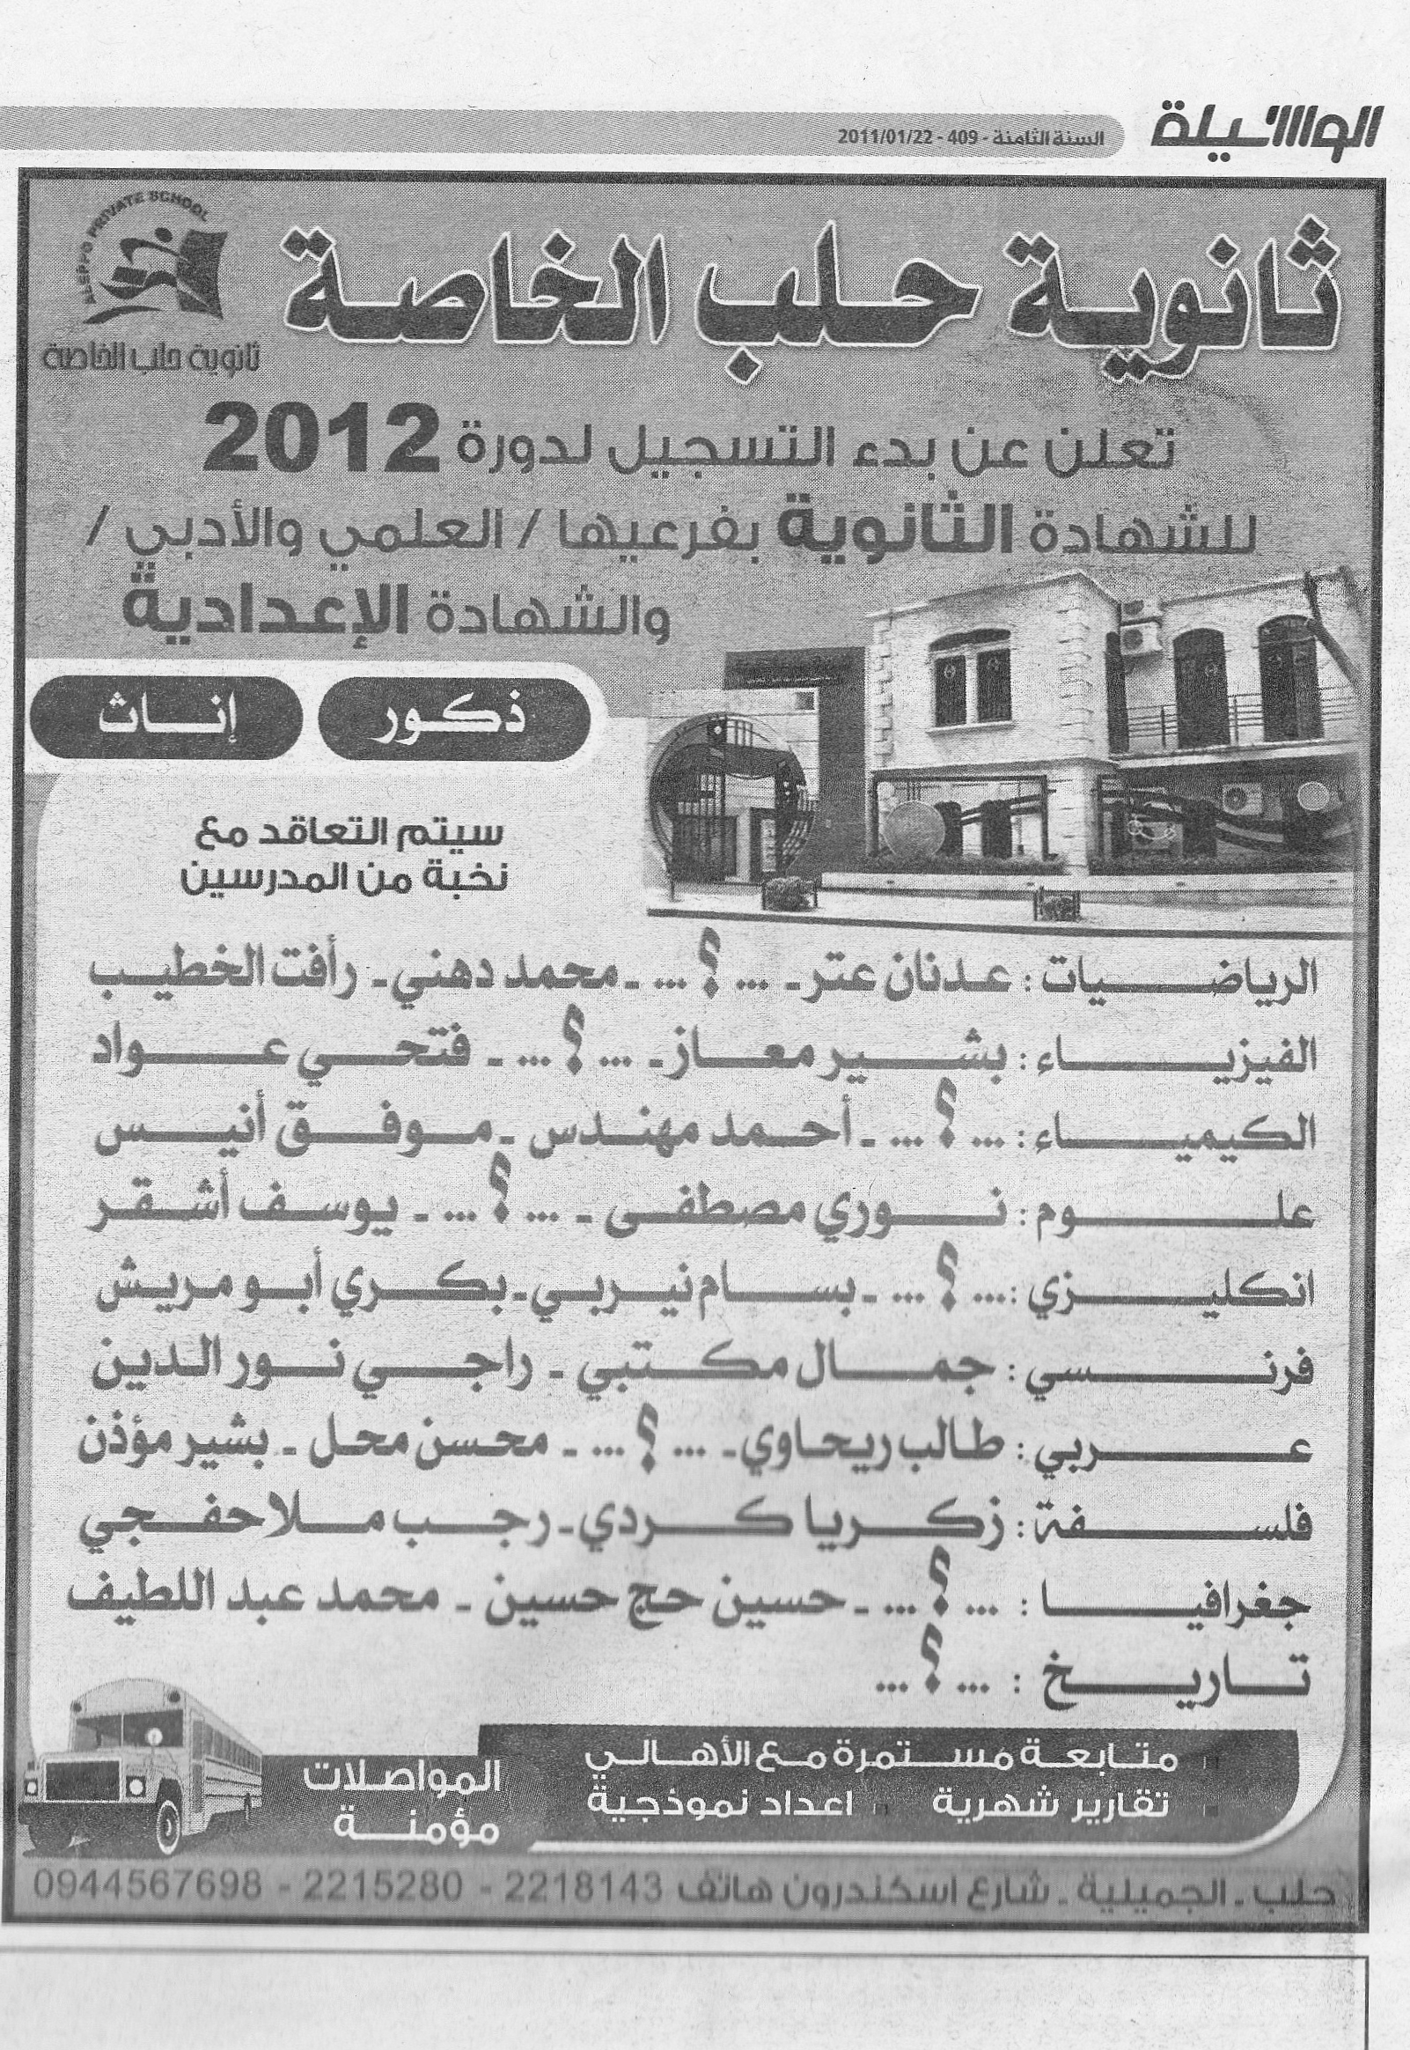

A private school (مدرسة خاصة)in the Middle East placed the ad at the left in a newspaper in order to attract more students—but they didn’t get as many new students as they expected!

In order to expand their market, they have hired you to create a television commercial to persuade people to attend their school.

Be sure to include:

* ما المواد التي\* ممكن تدرسها في المدرسة؟
* في أي فرع ممكن تدرس للثانوية العامة (علمي \ أدبي \ علمي وأدبي)؟

Feel free to be creative and insert information not in the ad in order to attract more students.

\*that/which