Giving a tour of your school
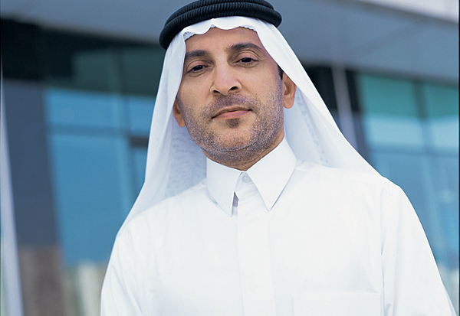
هناك رجل يزور مدرستك من قَطْر—ولكنَهُ لا يتكلم اللغة الإنكليزية!
Fortunately, your principal knows that you speak Arabic and has asked you and a friend to give your visitor a tour of the school.
With a partner, film yourselves giving a tour of the school to your visitor. Be sure to include:
- A general introduction to your school
- Point out at least one room that teaches each subject
- The library and main office
- Your Arabic classroom
- Introduce any teachers/administrators you see in the hallway
- Personal notes—what subject do you like? What period do you have it? Where do you eat lunch? Etc.
Examples of things you could say…
- هذه غرفة العلوم - هذا صديقي - هذا صف الإكليزية - etc.
Tour log:
We gave an introduction to our school in Arabic نعم لا
We mentioned the following places, and used the correct form of “this” to introduce each one:
Place/person introduced | Form of “this” used

As you watch your classmates’ videos, keep track of whether they used the correct form of “this” for each place/thing they mentioned by circling which one you hear.
What type of noun was used? | Which form of “this” did they use? | Was it pronounced correctly?
masc. singular – fem. singular  plural object – plural people | هذا – هذه - هؤلاء | نعم - لا
masc. singular – fem. singular  plural object – plural people | هذا – هذه - هؤلاء | نعم - لا
masc. singular – fem. singular  plural object – plural people | هذا – هذه - هؤلاء | نعم - لا
masc. singular – fem. singular  plural object – plural people | هذا – هذه - هؤلاء | نعم - لا
masc. singular – fem. singular  plural object – plural people | هذا – هذه - هؤلاء | نعم - لا
masc. singular – fem. singular  plural object – plural people | هذا – هذه - هؤلاء | نعم - لا
masc. singular – fem. singular  plural object – plural people | هذا – هذه - هؤلاء | نعم - لا
masc. singular – fem. singular  plural object – plural people | هذا – هذه - هؤلاء | نعم - لا
masc. singular – fem. singular  plural object – plural people | هذا – هذه - هؤلاء | نعم - لا
masc. singular – fem. singular  plural object – plural people | هذا – هذه - هؤلاء | نعم - لا
masc. singular – fem. singular  plural object – plural people | هذا – هذه - هؤلاء | نعم - لا
masc. singular – fem. singular  plural object – plural people | هذا – هذه - هؤلاء | نعم - لا
masc. singular – fem. singular  plural object – plural people | هذا – هذه - هؤلاء | نعم - لا
masc. singular – fem. singular  plural object – plural people | هذا – هذه - هؤلاء | نعم - لا
masc. singular – fem. singular  plural object – plural people | هذا – هذه - هؤلاء | نعم - لا
masc. singular – fem. singular  plural object – plural people | هذا – هذه - هؤلاء | نعم - لا
masc. singular – fem. singular  plural object – plural people | هذا – هذه - هؤلاء | نعم - لا
masc. singular – fem. singular  plural object – plural people | هذا – هذه - هؤلاء | نعم - لا
masc. singular – fem. singular  plural object – plural people | هذا – هذه - هؤلاء | نعم - لا
masc. singular – fem. singular  plural object – plural people | هذا – هذه - هؤلاء | نعم - لا
masc. singular – fem. singular  plural object – plural people | هذا – هذه - هؤلاء | نعم - لا
masc. singular – fem. singular  plural object – plural people | هذا – هذه - هؤلاء | نعم - لا
masc. singular – fem. singular  plural object – plural people | هذا – هذه - هؤلاء | نعم - لا
masc. singular – fem. singular  plural object – plural people | هذا – هذه - هؤلاء | نعم - لا
masc. singular – fem. singular  plural object – plural people | هذا – هذه - هؤلاء | نعم - لا
masc. singular – fem. singular  plural object – plural people | هذا – هذه - هؤلاء | نعم - لا
masc. singular – fem. singular  plural object – plural people | هذا – هذه - هؤلاء | نعم - لا
masc. singular – fem. singular  plural object – plural people | هذا – هذه - هؤلاء | نعم - لا
masc. singular – fem. singular  plural object – plural people | هذا – هذه - هؤلاء | نعم - لا
masc. singular – fem. singular  plural object – plural people | هذا – هذه - هؤلاء | نعم - لا
masc. singular – fem. singular  plural object – plural people | هذا – هذه - هؤلاء | نعم - لا

