Nawf Abou-Dib
Dearborn Dearborn High School

“Aligning Common Core Literary Standards with Arabic Classroom Instruction”
Questions to consider
- What are the Common Core State Standards “CCSS”?
- What are the 5Cs for teaching Arabic as a World Language?
- How can we link CCSS to Arabic language learning and teaching?

Unit Design
- Unit 1: Telling Time/Calendar

CCSS:
- RL.4.1: Refer to details and examples in a text when explaining what the text says explicitly and when drawing inferences from the text.
- RL.4.3: Describe in depth a character, setting, or event in a story or drama, drawing on specific details in the text (e.g., a character’s thoughts, words, or actions).
- RI.4.3: Explain events, procedures, ideas, or concepts in a historical, scientific, or technical text, including what happened and why, based on specific information in the text.
- RF.4.4: Read with sufficient accuracy and fluency to support comprehension.
- RF.4.4 (a): Read on-level text with purpose and understanding.
- RF.4.4 (b): Read on-level text orally with accuracy, appropriate rate, and expression on successive readings.
- W.4.2: Write informative/explanatory texts to examine a topic and convey ideas and information clearly.
- SL.4.1: Engage effectively in a range of collaborative discussions (one-on-one, in groups, and teacher-led) with diverse partners on grade and level appropriate topics and texts, building on others’ ideas and expressing their own clearly.
- SL.4.1(c): Pose and respond to specific questions to clarify or follow up on information, and make comments that contribute to the discussion and link to the remarks of others.
- SL.4.1 (d): Review the key ideas expressed and explain their own ideas and understanding in light of the discussion.
- L.4.5: Demonstrate understanding of figurative language, word relationships, and nuances in word meanings.
- L.4.5 (a): Sort words into categories (e.g., colors, clothing) to gain a sense of the concepts the categories represent.

WL Standards

Communication:

Standard 1.1: Students engage in conversations, provide and obtain information, express feelings and emotions, and exchange opinions.
Standard 1.2: Students understand and interpret written and spoken language on a variety of topics.
Standard 1.3: Students present information, concepts, and ideas to an audience of listeners or readers on a variety of topics.

Cultures:

Standard 2.1: Students demonstrate an understanding of the relationship between the practices and perspectives of the culture studied.

Connection:

Standard 3.1: Students reinforce and further their knowledge of other disciplines through the world Language.
Standard 3.2: Students acquire information and recognize the distinctive viewpoints that are only available through the target language and its cultures.

Comparisons:

Standard 4.1: Students demonstrate understanding of the nature of language through comparisons of the language studied and their own.
Standard 4.2: Students demonstrate understanding of the concept of culture through comparisons of the cultures studied and their own.

Community:

Standard 5.1: Students use the language both within and beyond the school setting.

LESSON PLAN
Intermediate Level
Topic: Telling Time/Calendar

Theme question: How does a calendar help us remember important dates?

1- Lesson Preparation:
A- Content Objective:
I can demonstrate comprehension of the relationship between months, seasons, and years by calculating class statistics using graphs, and by Comparing and contrasting Gregorian and Islamic calendars.
B- Language Objectives:
I can orally share in small groups the month, season, and year by using this sentence stems supporting passive voice:
“I was born …..”
“The year I was born …”
“I was born during the ………season.”
“ Thanksgiving is celebrated on ----.”
“ Eid Al-Adhah is celebrated during ------this year.”
“When where you born?”
“ My favorite season is ---- what is your favorite season?
“Do you like your day of birth?”
I can work in a small group to create graphs representing our class percentages of date of birth, month, year, and season, Then to write a short essay, using these words: more than, less than, percentage, compare, total
C- Supplemental Materials:
Posters displayed in the classroom, words bank, examples of graphs, calculators and or computers.

2- Building Background:
A- Daily bell work starts with the day date, e.g.
الإثنين 1 تشرين الثاني / نوفمبر 2013
B- Read BW randomly

C- Show a 3-4 minute documentary about the four seasons in Arabic
D- Display materials and posters in the class room
E- Explain the passive voice and give examples

3- Comprehensive Input:
Identify in the class the poster that has the months
Identify in the class the poster that has the days
Identify in the class the poster that has the seasons
Identify the passive voice in a set of sentence
4- Strategy: Adapted from the Nebraska K-12 Foreign Language Frameworks, 1996
STUDENTS WITH DIVERSE TALENTS
Interaction, Practice & Lesson Delivery
Intelligence | Students learn best by | Planning questions for teachers | Learning activities
Linguistic   | Verbalizing, hearing, and seeing words  Introduce a series of words ( the 4 seasons, months, years, days of the week and numbers1-31) verbally and visually | How can I use the spoken or written words  Pose a series of questions for students to answer such as  كم عمرك؟  في اية سنة وُلدت؟  هل وُلدت في فصل الخريف؟  من وُلِدَ في شهرتشرين الثاني/ نوفمبر؟ | Words-used in reading, writing and speaking  students must say or answer a series of sentences or answer questions, such as  عمري ----سنة.  وُلدت في سنة 1998.  لا ، لقد وُلدتُ في فصل ------.
Logical-Mathematical  %  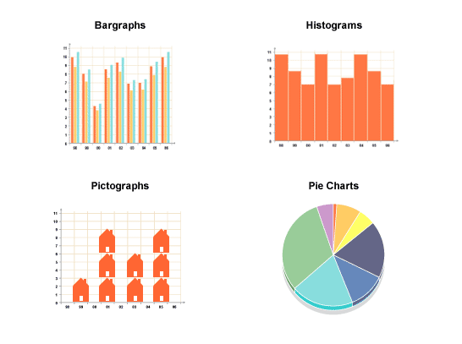 | Conceptualizing it, quantifying it, thinking critically about it  Give students a statistic chart to figure out the class percentages  -Convert the information into a graph form | How can I bring in numbers, calculations, logic, classifications, or critical thinking?  Ask students questions such as:كم عدد الطلاب الذين وُلِدوا في سنة 1997؟ | Counting + Graphic organizers  Create a bar graph representing the class percentages of date of birth, month, year, and season
Spatial   | Drawing it, sketching it, visualizing it  Use different colors | How can I use visual aids visualization, color, art, or metaphor  Ask students questions such as:  برأيكم ما هي ألوان فصل الربيع؟  (students may have different opinion about the colors) | Color schemes  Students use different colors for different seasons, months and years and or do a sketch for each item.

5- Assessment:
- Formative: (20%) bell work/classwork/homework/note taking/participation
- Summative: (80%) reading/oral presentation/project/quizzes and unit test.

PROJECT

My Birth Date

IN ARABIC

Step 1: On a flash card write down your name and your date of birth, include the following: (10 points)

- The year
- The season
- The month
- The day
- The exact date

Step 2: On the back of the flash card, you have to write down 4 sentences using the passive voice, e.g. (10 points)

- I was born -----------
- The year I was born -------------
- I was born during the ------------season.

Step 3: Class will work as a whole to do the statistic, e.g.
Who was born in 1995? Count the students ( all students should be doing the counting)
You should use full sentences in your answers.
من وُلِد في سنة 1995؟
ثلاثة طلاب وُلِدوا في سنة 1995.

You should register the information in the following chart then work in a small group to create a bar graph representing our class percentages of date of birth, month, year, and season using these words: more than, less than, percentage, compare, total (10 points)

إحصاء
النسبة المِئَوِية للطلاب والطالبات الذين وُلِدوا في
سنة
1999 | 1998 | 1997 | 1996 | 1995

فصل
الخريف | الصَيْف | الربيع | الشِتاء

شهر
تشرين الأوّل | تمّوز | نيسان | كانون الثاني
تشرين الثاني | آب | أيّار | شباط
كانون الأوّل | أيلول | حزيران | آذار

يوم
السبت | الجمعة | الخميس | الأربعاء | الثلاثاء | الإثنين | الأحد

تاريخ
خمسة | اربعة | ثلاثة | اثنان | واحد
عشرة | تسعة | ثمانية | سبعة | ستة
خمسة عشر | اربعة عشر | ثلاثة عشر | اثنا عشر | احد عشر
عشرون | تسعة عشر | ثمانية عشر | سبعة عشر | ستة عشر
خمسة وعشرون | اربعة وعشرون | ثلاثة  وعشرون | اثنان  وعشرون | واحد  وعشرون
ثلاثون | تسعة  وعشرون | ثمانية وعشرون | سبعة  وعشرون | ستة  وعشرون
 |  |  |  | واحد وثلاثون

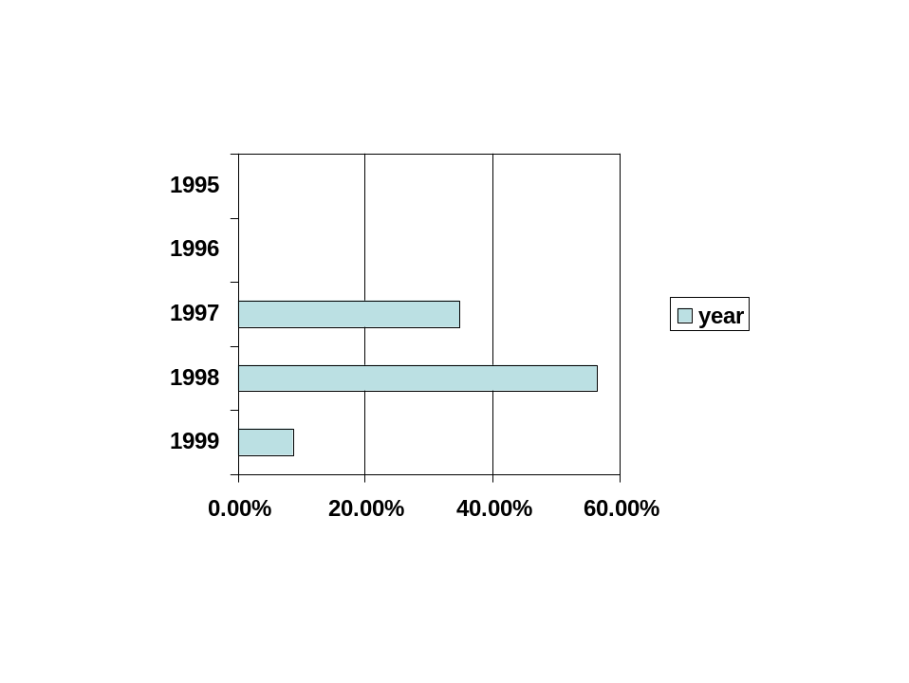

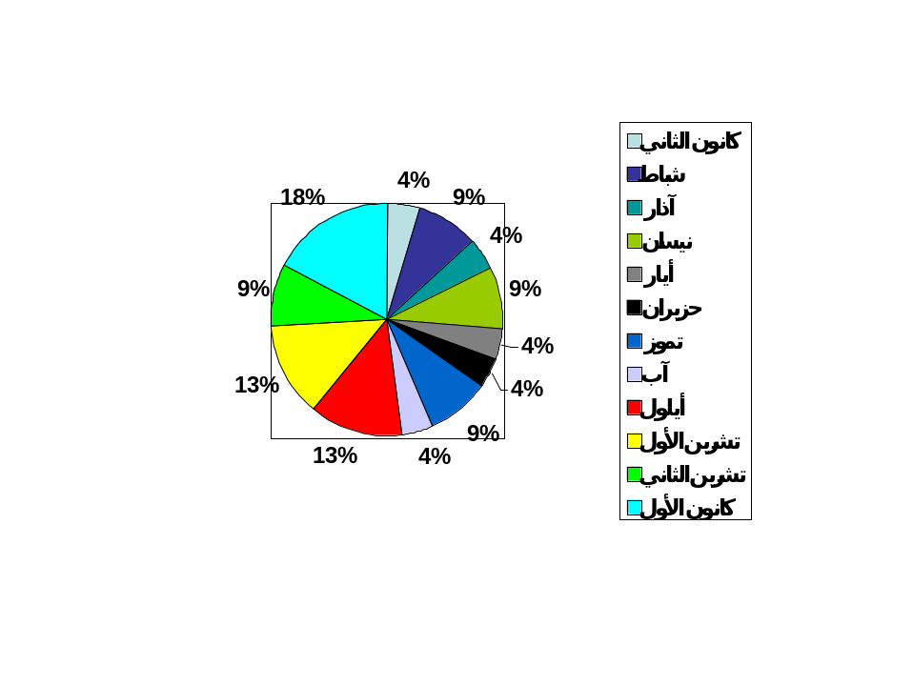

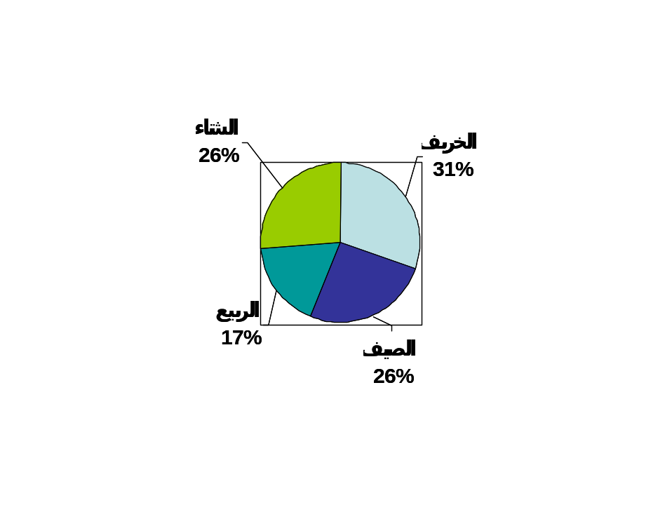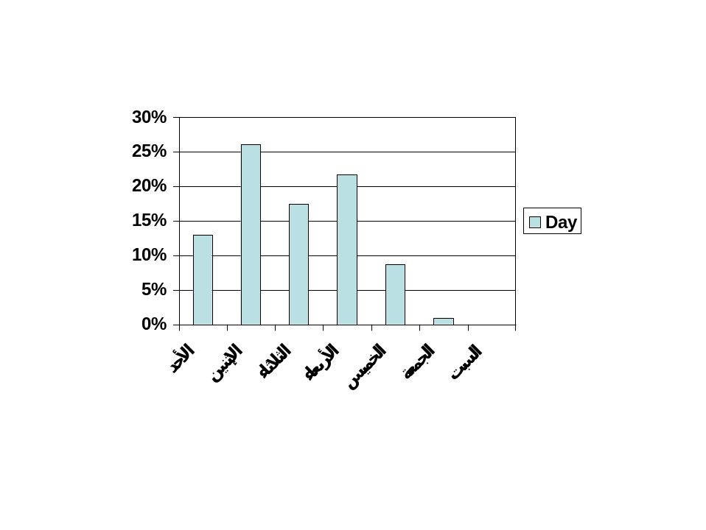

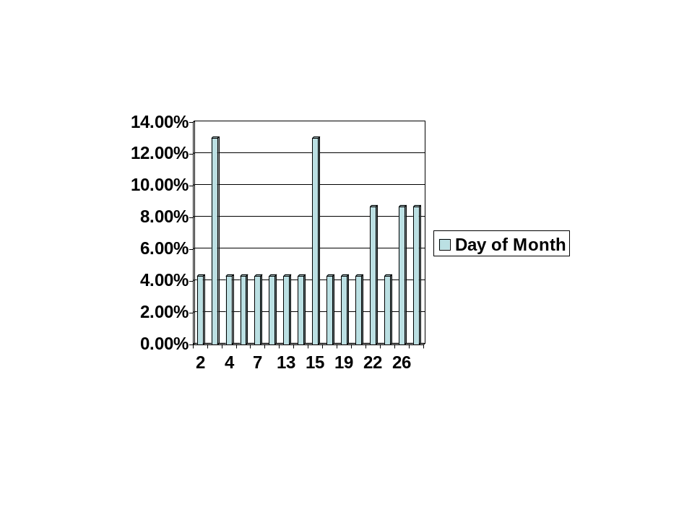

Project
Calendar

In Arabic
Step 1: You are going to be assigned one month of the Gregorian calendar and one month of the Islamic calendar

Step 2: Design your calendar in accordance to the months you are assigned to do. Designs could be related to specific holidays or the weather.

Step 3: List all holidays and important occasions.

Step 4: Work in groups to compare and contrast your months/ similarities and differences between the two calendars using full sentences orally then in writing using the passive voice and words to compare and contrast such as: مثل- يشبه- بعكس- بينما- أطول- أقصر- قبل- بعد- إلخ
مثال:
أشهر السنة ------- أطول من أشهر السنة -------.
يُحتفل بعيد ------ في شهر ------- بينما يُحتفل بعيد ------- في شهر -------.

Step 5: Use your sentences to write a compare and contrast short essay.

Calendar Assessment List
Element |  | Possible Points |  | Earned  Assessment
 |  |  |  | Self |  | Teacher
Focus  The calendar is clear when you first look at it. |  | 3
Drawing and Illustration  All Illustrations and drawings add to the purpose and interest of the calendar. |  | 3
Layout and Design  The overall organization, design, use of color, and use of space help to make the calendar interesting and to communicate the message. |  | 3
Purpose  The purpose of the calendar is clearly accomplished |  | 3
Neat and Presentable  The calendar is neat and presentable |  | 3
Writing |  |  |  | Self |  | Teacher
Main Ideas  The main ideas are appropriate to the topic and are presented correctly. |  | 5
Supporting Details  Appropriate and accurate details support each main idea. |  | 5
Mechanics  There are no errors in usage and spelling. |  | 5
 | Total |  | 30

