Lesson Plan: Arabic Level 2 (Novice)
Lesson Focus | What would I study in school in an Arab country?
Time Suggested | 50 minutes
Materials needed | Authentic materials, worksheets (see appendices)
Objectives, and standards | By end of this lesson student will be able to do the following:  - Tell the subjects which are included in the فرع علمي course of study in the Arab world and the فرع أدبي course of study.  - Use the culturally specific vocabulary word الثانوية العامة in context  - Compare and contrast between the American school system and an Arab school system, focusing on الثانوية العامة and الفرع الأدبي \ الفرع العلمي  - Ask and answer questions about preferences for certain features of school  - Collect factual information and make inferences from authentic documents  Standards:  Interpersonal Communication: Learners interact and negotiate meaning in spoken, signed, or written conversations to share information, reactions, feelings, and opinions.  Interpretive Communication: Learners understand, interpret, and analyze what is heard, read, or viewed on a variety of topics.  Relating Cultural Products to Perspectives: Learners use the language to investigate, explain, and reflect on the relationship between the products and perspectives of the cultures studied.  Acquiring Information and Diverse Perspectives: Learners access and evaluate information and diverse perspectives that are available through the language and its cultures.  Cultural Comparisons: Learners use the language to investigate, explain, and reflect on the concept of culture through comparisons of the cultures studied and their own.
Opening Routine/Activities | When students come in, they see a warm-up already on the board for them to start as the bell rings. The warm-up asks them to write as much as they can in Arabic about the movie Syrian Schools: Episode 4: Marked for Life (https://vimeo.com/album/2226285/video/10086740).  The movie centers on two girls, فرح and رهف. One is studying for the ثانوية عامة in sciences, while the other is studying for humanities.  Prompt: “What do you remember about the two sisters we saw in Syrians Schools? Write as much as you can in Arabic about each:  - فرح...  - رهف...  - الامتحان الكبير...  Prior knowledge needed: names of school subjects in Arabic.
Main Learning Activities | Main activities:  - Review the warm-up with the students. Teacher can have students share in pairs, esp if they appear to be struggling, then share with the group. Teacher should try to elicit through discussion in Arabic the fact that فرح studies subjects in the humanities such as الأدب، التاريخ، اللغة الإنكليزية and رهف studies subjects mainly in the sciences such as الرياضيات، الكيمياء etc.  - Teacher segues from the discussion of the movie to introduce the three vocabulary words of the day. He/she connects them back to movie and the previous discussion.  - الفرع الأدبي  - الفرع العلمي  - الثانوية العامة  - Strengthen the connection between these ideas and previous vocabulary: Ask students to brainstorm as many subjects as they know how to say in Arabic that would be studied in each فرع.  - Students ask as many classmates as they can whether they would want to study in الفرع الأدبي or الفرع العلمي. Challenge them to ask لماذا؟ and use لأنّ in their answers. Give students a sheet (appendix i) where they can record their answers. After students have exchanged information in Arabic, teacher leads a discussion by asking “كم طالباً يريد أن يدرس في الفرع العلمي؟ في الفرع الأدبي؟ من؟ لماذا؟” Teacher can call on individual students to share their poll results and/or reasons.  - Students practice reading and examining authentic documents related to the ثانوية عامة (appendix iii). Teacher should challenge students not only to answer the questions but also to cite information from the texts that supports their answers.  - Students ask each other whether they would prefer to study in المدرسة الأمريكية or الثانوية العامة, again challenging each other to say why. Give students a sheet (appendix ii) where they can record their answers. Again, teacher leads students in a debrief.
Closure | Teacher asks students to complete a homework assignment: Imagine that you have gone to study abroad in the Middle East and you’ve been dropped into an Arabic-speaking school that uses the ثانوية عامة system. Write a short blog post in Arabic (5-6 sentences) describing your experience for someone who is unfamiliar with it.
Assessment & Record Keeping | - Teacher observes student answers during warm-up to assess readiness to talk about the subject  - Teacher observes student interactions during interpersonal speaking  - Teacher assesses student work by collecting reading assignment  - Teacher assesses students’ overall grasp of the lesson by collecting the homework assignment later
Additional Planning Decisions
Post-Lesson Follow-ups | - What went well?  - What needs more work in the next class/ lesson?  - What activities should I do differently next time?

Appendix i: Sheet for students to record each others’ answers
Find out who in your class would want to study in الفرع الأدبي if they lived in the Middle East and who would want to study in الفرع العلمي. Be sure to ask them why and record some of the reasons you heard.
الفرع العلمي | الفرع الأدبي
لماذا؟ | لماذا؟

Appendix ii: Sheet for students to record each others’ answers
Find out who in your class would like to study in the ثانوية عامة system and who likes their American school. Ask for a reason and record what you hear!
الثانوية العامة | مدرسة أمريكية
لماذا؟ | لماذا؟

Appendix iii: Authentic materials for reading:
قراءات – الثانوية العامة
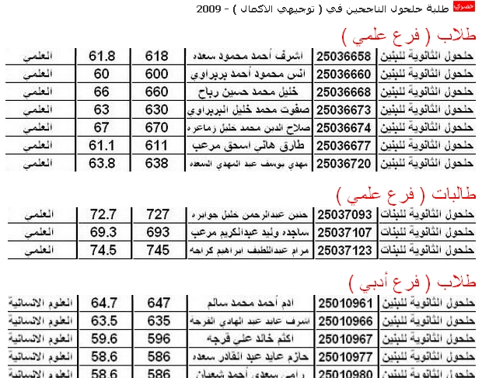
Look at the exam results above. What categories are they divided into? Cite an example or quotation from the text that supports your assertion.
Category | Example or quotation that supports your answer

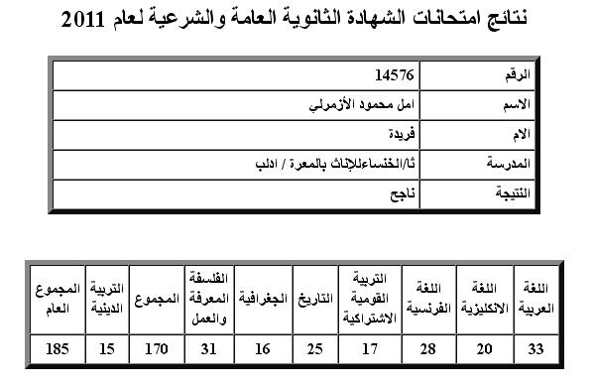
Above is an example of ثانوية عامة results.
What فرع do you think this person studied in? Cite examples or quotations from the text that support your answer.
الفرع | Examples or quotations that support your answer

