STRATEGY 1: Cooperative and Collaborative Learning
Cooperative or collaborative learning is a team process
where members support and rely on each other to achieve an agreed-upon goal. The classroom is an excellent place to develop team-building skills you will need later in life.
Cooperative/collaborative learning is interactive;
as a team member, you:
- develop and share a common goal
- contribute your understanding of the problem:
questions, insights and solutions
- respond to, and work to understand, others' questions, insights and solutions.
Each member empowers the other to speak and contribute,
and to consider their contributions
- are accountable to others, and they are accountable to you
- are dependent on others, and they depend on you
What makes for a good learning team?
- Team activities begin with training in, and understanding group processes.
An instructor begins by facilitating discussion and suggesting alternatives
but does not impose solutions on the team, especially those having difficulty working together
- Three to five people
Larger teams have difficulty in keeping everyone involved
- Teacher-assigned groups
They function better than self-assigned groups
- Diverse skill levels, backgrounds, experience
  - Each individual brings strengths to a group
  - Each member of the group is responsible to not only contribute his/her strengths, but also to help others understand the source of their strengths
  - Any member who is at a disadvantage or not comfortable with the majority should be encouraged and proactively empowered to contribute
  - Learning is positively influenced with a diversity of perspective and experience increasing options for problem solving, and expanding the range of details to consider
- Commitment of each member to a goal
that is defined and understood by the group
  - Confidential peer ratings are a good way to assess who is and who is not contributing
  - Groups have the right to fire a non-cooperative or non-participating member if all remedies have failed.
(The person fired then has to find another group to accept him/her)
  - Individuals can quit if they believe they are doing most of the work with little assistance from the others.
(This person can often easily find another group to welcome his/her contributions)
- Shared operating principles and responsibilities,
defined and agreed to by each member. These include:
  - Commitment to attend, prepare and be on time for meetings
  - Have discussions and disagreements focus on issues, avoiding personal criticism
  - Take responsibility for a share of the tasks and carry them out on time
You may need to perform tasks that you have little experience, feel ill-prepared for, or even think others would do better. Accept the challenge, but be comfortable in stating that you may need help, training, a mentor, or have to resign and take on different task.
Process:
- Set up goals, define how often and with what means you will communicate, evaluate progress, make decisions, and resolve conflict
- Define resources, especially someone who can provide direction, supervision, counsel, and even arbitrate
- Schedule review of your progress and communication
to discuss what is working and what is not working
Teams with problems should be invited or required to meet with the instructor to discuss possible solutions.
* "Cooperative learning" is often used in K-12 education, and "collaborative learning" in higher education See also:
Online Collaborative Learning in Higher Education, primary sites a web site devoted to world's best practice in online collaborative learning in higher education, and related topics. Tim Roberts, Faculty of Informatics and Communication, Central Queensland University, Bundaberg, Queensland 4670 Australia
"Cooperative learning in technical courses: procedures, pitfalls, and payoffs", Richard M. Felder, North Carolina State University & Rebecca Brent, East Carolina University

STRATEGY #2: Active listening

What affects listening?
Active listening intentionally focuses on who you are listening to,
whether in a group or one-on-one, in order to understand what he or she is saying.
As the listener, you should then be able to repeat back in your own words what they have said to their satisfaction. This does not mean you agree with the person,
but rather understand what they are saying.
What do you think of the  subject matter?  Have you a lot of experience with it?  Will it be hard to understand, or simple?  Is it important to you, or just fun? | Is the speaker experienced or nervous?  What are his/her non-verbal cues?  What frame of mind is he or she?  How personable, threatening, intelligent, etc.?
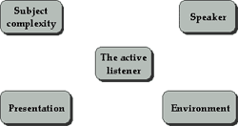
Is the message illustrated with  with visuals or examples?  Is technology used effectively?  Are concepts introduced incrementally,  or with examples? | Is the space conducive to listening?  or to interaction or exchange  with the speaker?  Are there avoidable distractions?

Described above are the external factors.
Now: what about you, the center, the listener?

Prepare with a positive, engaged attitude
- Focus your attention on the subject
Stop all non-relevant activities beforehand to orient yourself
to the speaker or the topic
- Review mentally what you already know about the subject
Organize in advance relevant material in order to develop it further
(previous lectures, TV programs, newspaper articles, web sites, prior real life experience, etc.)
- Avoid distractions
Seat yourself appropriately close to the speaker
Avoid distractions (a window, a talkative neighbor, noise, etc.)
- Acknowledge any emotional state
Suspend emotions until later, or
Passively participate unless you can control your emotions
- Set aside your prejudices, your opinions
You are present to learn what the speaker has to say,
not the other way around

Actively listen
- Be other-directed; focus on the person communicating
Follow and understand the speaker as if you were walking in their shoes
Listen with your ears but also with your eyes and other senses
- Be aware: non-verbally acknowledge points in the speech
Let the argument or presentation run its course
Don't agree or disagree, but encourage the train of thought
- Be involved:
Actively respond to questions and directions
Use your body position (e.g. lean forward) and attention to encourage the speaker and signal your interest

Follow up activities
One-to-one
Give the speaker time and space for rest after talking
Express appreciation for the sharing to build trust and encourage dialogue
Check if you have understood
- Restate key points to affirm your understanding & build dialogue
- Summarize key points to affirm your understanding & build dialogue
- Ask (non-threatening) questions to build understanding
Continue dialogue:
- Reflect on your experience to demonstrate your interest (feedback)
- Interpret after you feel you have grasped content
- Apply what you have learned to a new situation
In a group or audience
give the speaker space to regroup, to debrief after talking

During Q & A
If posing a question
- Quickly express appreciation
- Briefly summarize a preliminary point
- Ask the relevant question
If making a point
- Quickly express appreciation
- Briefly restate the relevant idea as presented
- State your idea, interpretation, reflection
- Invite a response
Continued development
- Get contact information for later reference
- Invite friends/colleagues/etc. for discussion afterward
- Write out a summary with questions for further review

STRATEGY #3: Pre-reading Strategies
What you bring to the printed page
will affect how you understand what you read,
and may be what is most important in understanding what you read
Organize yourself before you read

Strategies to activate your prior knowledge:
Brainstorming:
Examine the title of the selection you are about to read
List all the information that comes to mind about this title
Use these pieces of information to recall and understand the material
Use this knowledge to reframe or reorder what you know, or to note what you disagree with, for further research
Group discussions:
Group discussions in and out of class will help you to discover what you bring to your reading, what your fellow students bring, as well as shared experiences
If you find they have new background information, ask for more information from them
Concept or mind mapping:
This is a type of brainstorming where you place the title/subject as the main idea,
then develop a "mind map" around it. It can be effective either in a group or by yourself
Pre-questions:
Often chapters in texts provide organizing questions.
You can also write out a series of questions you expect to be answered when reading:
Examples:
Definition:
What is....? Where does ... fit? What group does ... belong to?
Characteristics:
How would I describe...? What does ... look like? What are its parts?
Examples
What is a good example of ...?
What are similar examples that share attributes but differ in some way?
Experience
What experience have I had with ....? What can I imagine about ...?
Visual Aids:
Pictures and other visual material can activate your prior knowledge.
Use the Internet to search for pictures related to your title/topic to give you visual images of what you are about to read.
Advance Organizers:
Relate new reading material to something you already know, to your background or experiences. Ask your teacher for assistance in developing these.

Additional Pre-reading Strategies:
Overviews:
Discussing information about the selection or assignment prior to reading must take place.
This may take the form of class discussions, printed previews, photographs, outlines, or films.
Vocabulary Previews:
Unfamiliar key words need to be taught to students before reading so that new words, background information, and comprehension can improve together.
List all words in the assignment that may be important for students to understand. Arrange words to show the relationships to the learning task. Add words students probably already understand to connect relationships between what is known and the unknown. Share information with students. Verbally quiz them on the information before assigned reading begins.
Structural Organizers: Before reading an assignment, basic frameworks which are included in the text should be pointed out such as cause-effect or problem-solution. It can be beneficial to call attention to specific plans of paragraph or text organization such as signal words, main idea sentences, highlighted phrases, headings and subtitles. A review of skimming techniques might also be appropriate as these various areas are covered.
A Purpose for Reading: When students have a purpose for reading a selection, they find that purpose not only directs their reading towards a goal, but helps to focus their attention. Purposes may come from teacher directed questions, questions from class discussions or brainstorming, or from the individual student. Along with the question, it is a good idea to pose predictions of the outcome and problems which need to be solved. These may be generated by the student or the teacher, but the teacher should use these to guide students in the needed direction for the assigned selection.
Author Consideration: Depending upon the content area, a discussion of the author of the particular work can be helpful to the understanding of it. What is the author trying to say? What is his point of view and his reason for writing the particular work?

STRATEGY #4 Memorizing using keywords
For foreign language vocabulary, select a key word in English that sounds like the foreign word.
Next, imagine an image which involves the key word with the English meaning of the foreign word.
Search terms or keywords can provide a strategy
towards memorizing important information!
Try this exercise with a passage or chapter from your reading:
- Write down key words and phrases of your text
on a separate piece of paper, .
- Combine these words or phrases into your own sentences
and compare with the original text
- Select a keyword or phrase that summarizes your work
and that will help you recall the information
- Create a mental image of the keyword,
or even create a story about the word to memorize more detail of the original text.

STRATEGY #5 Memorizing using imaging

Memorization using mental imaging, or image-naming: creating relationships between the name and the physical characteristics of a person
Simply invent any relationship between the name and the physical characteristics of the person.
For example, if you had to remember someone you met with the name Shirley,
you might keep the name in memory by noticing that she has (or has not!) "curly" (rhymes with Shirley) hair.
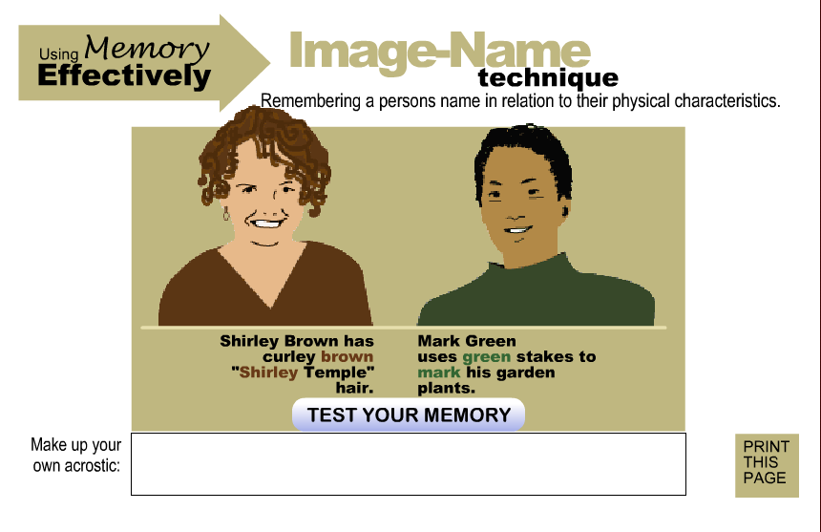
Use our exercise to draw images to practice visualizing vocabulary words
"...visual inspection and verbal elaboration — resulted in improved memory results,
according to Kirchhoff (2006). "Those individuals who used the first two strategies often had better memory performance than those who used them rarely or not at all," said Kirchhoff. "There's a great deal of variability in strategy use when people are free to choose their own learning techniques. We also discovered that individual people use multiple strategies to learn new information."

All the lised above strategies where taken from Resource : http://www.studygs.net/memory/memimage.htm

