Introduction
This mini-unit is meant to be the finale of a larger unit on the Middle East. By the time this lesson is taught, students should have a thorough grounding in the religions, ethnicities, and geography of the area. These three lessons should be used as culminating activities, or as a jumping-off point for a study of current-day issues in the Middle East. The first lesson gives students the opportunities to put themselves in the shoes of those people who were affected by the imperialism and colonialism of the great powers. Students decide how the region should be divided up, and who should get what based on the goals and ideals of the actual people who lived in the Middle East. In the second lesson, students learn about the imperial history of the region, looking at the series of overlapping treaties and agreements after the First World War, and creating a comprehensive class map of the region as it was in 1925. Students will investigate the “why” of colonialism, and delve into the reasons the UK and France (but also Russia, Italy, the US, and Turkey) were so interested in the region. In the third, culminating lesson the students will use the background given by the other two lessons as a lens to look at the Middle East today. What conflicts are there? What were the causes of the conflicts? In a class discussion, students will discuss the plausibility of the goal of “peace in the Middle East,” and will create their own maps of a “conflict-free” Middle East.

These lessons can be scaffolded for any high school grade and are meant for a World History, 20th Century History, or Current Events class.

Standards:
Common Core
Reading
- Cite specific textual evidence to support analysis of primary and secondary sources, attending to such features as the date and origin of the information.

Writing
- Conduct short as well as more sustained research projects to answer a question (including a self- generated question) or solve a problem; narrow or broaden the inquiry when appropriate; synthesize multiple sources on the subject, demonstrating understanding of the subject under investigation.
- Draw evidence from informational texts to support analysis, reflection, and research.

Oregon State Social Studies
- HS.16. Analyze the interconnectedness of physical and human regional systems (e.g., a river valley and culture, water rights/use in regions, choice/impact of settlement locations) and their interconnectedness to global communities.
- HS.19. Evaluate how differing points of view, self-interest, and global distribution of natural resources play a role in conflict over territory.
- HS.61. Analyze an event, issue, problem, or phenomenon, identifying characteristics, influences, causes, and both short- and long-term effects.
- HS.62. Propose, compare, and judge multiple responses, alternatives, or solutions to issues or problems; then reach an informed, defensible, supported conclusion.

Lesson Plan 1
Topic - The Middle East after WWI: Middle East for Middle Easterners
Time - 90 min
EQ - How would the people who lived in the Middle East during and after WWI divide up their land and resources?
Objectives - Students will be able to understand the various goals, priorities, and motivations of multiple ethnicities, religions, and political groups in the Middle East. Students will be able to understand the difficulty in dividing up land and resources within the Middle East.

- (10 min) As a class, brainstorm some goals that people living in the Middle East might have. Divide students into groups of 5 (it doesn’t matter how many groups there are). Randomly assign each student in the group one of the 5 roles (feel free to create different groups based on other criteria/let students develop their roles):
  - Family of Saud
  - Faysal/Husyan Family
  - Ottoman Empire
  - Zionist
  - Shia Muslim
- (7 min) Tell students to remember their original group, and then ask students to find the others who have their roles (i.e. Ottoman Empire with other Ottoman Empire, etc). When they are in their role groups, ask them to write down a list of three things they already know about their “roles” - can be who they are, what they believe, where they live, what their goals are, what is important, etc.
- (20 min) When groups have come up with their prior knowledge list, hand out readings. Role groups read together, and then come up with a list of 3 goals for their role. If my role was Zionist, my goals might be an exclusively Jewish nation in the Middle East, the development of a large Jewish community composed of Middle East and European Jews, and access to Jerusalem and other Jewish holy sites in the Middle East. Model these goals for your students. Give them time to research (using the Internet, textbooks, primary sources you have access to, notes from previous classes, etc) and come up with goals. If they are done quickly, ask them to think about their group’s enemies and allies, and how they might be prepared to accomplish their goals.
- (25 min) When all role groups have come up with their three goals, ask students to copy down their role group goals, and then meet back with their original groups. Pass out the blank maps. Each role should present their goals and then, as a group, they should decide how to divide up the Middle East. Who gets what? Ask them to draw boundaries of states, city-states, zones, whatever they come up. Give or present them with some creative examples - create nation- or city-states, develop international zones, separate by majority religions or ethnicities, divide by latitude or longitude, keep the ME as one whole free zone w/ provinces, or keep the Ottoman Empire going, etc. Each group should also write a couple sentences describing their map.
- (20 min) When all groups are done dividing up their maps, they should present the maps (using the document camera) and explain what their reasoning was.
- (8 min) EXIT SLIP- Individually, students should compare their group’s map to the goals their role groups came up with. Did they get what they wanted? How hard was it? Do you think your map would work in reality?
- HOMEWORK - students should read Balfour Declaration, Sykes-Picot, Husyan/McMahon correspondence (as much/as little is appropriate for your students).

Lesson Plan 2
Topic - The Middle East after WWI: Middle East for the Great Powers
Time - 90 min
EQ - Why were the “great powers” so interested in the Middle East?
Objectives - Students will be able to understand and articulate the reasoning behind colonial imperialism in the Middle East. Students will be able to develop understanding of how the Middle East was divided after WWI and the fall of the Ottoman Empire.

- (10 min) Review homework reading. Did students find anything interesting about the documents? What did they notice?
- (7 min) Divide students into original groups of 5 from last lesson. Have students review their maps and role goals (or can divide students into groups of 3, or have them work individually). Have groups come up with some possible reasons the UK and France might be so interested in the Middle East both in the past, and in the present.
- (20 min) In groups, have students distill the main points of each of the four primary documents. Make sure they are doing this as a discussion rather than just one person writing and the others copying (see worksheet 2). Feel free to scaffold this reading to sections of the primary documents, or limit to 1 or 2 documents as is appropriate for your class.
- (15 min) When they are done with the main points, go over this as a class (perhaps copy down some of the points students suggest on the doc camera).
- (10 min) In their groups, ask students to pick two of the primary docs and compare and contrast them, listing at least three points (see worksheet 2).
- (15 min) As a class, create a comprehensive map of all the overlapping agreements. Do your students notice anything? Wrap up discussion as whole class or in groups.
- (13 min) Introduce and begin work on final assessment (see final assessment).

Lesson Plan 3
Topic - The Middle East after WWI: Middle East from a Current Perspective
Time - 90 min
EQ - How are the problems that the Middle East is experiencing now related to how it was divided up after WWI?

- (10 min) Time for finishing final assessment as need (should be homework, and due at end of the period).
- (10 min) Compare map created from last class to a current map of Middle East. Are they similar, different? Compare both maps to some of the maps created by groups in the first lesson (use doc camera, ask groups to present their maps again).
- (10 min) Class brainstorm of issues/events that are happening in the Middle East right now (i.e. Arab Spring, ISIS, oil, Islamic fundamentalism).
- (20 min) Pick one or two issues (you might also assign students to pick a major issue/goal from the first lesson), and ask class to do research and discover some more background information on the topic (using computers/iPads, or prepare notes yourself on issues you think are important). Students share research they think is important. (BBC, al-Jazeera, NYTimes, Haaretz are all good resources) – Kurd independence and ISIS make great case studies, as well as the interconnected and overlapping insurgencies during the US engagement in Iraq.
- (10 min) Connect current issues to historical events studied in the last two lessons. Ask students to come up with some ways that the division of the Middle East might affect current day Middle East.
- (10 min) Individual writing on peace in the Middle East (see worksheet 3)
- (20 min) Circle Discussion - have students move desks/chairs into circle. Place yourself outside the circle as a moderator and remind students that they should address their remarks to each other, not to you (a good tactic for this is to look down or away while they are talking). Ask students to share their views on the Middle East now, the various maps they’ve looked at and created, as well as the writing they just did on the Middle East. Tell students that they will be graded on participation, and remind students that everyone needs to contribute something to the discussion. Some possible discussion prompts:
  - Do you think other countries (like the US) should have a say in what goes on there? Is it ever ok to intervene in other countries’ affairs?
  - Do you think your individual map is feasible? Why/why not?
  - Why was the ME divided up after the fall of the Ottoman Empire? What were some alternatives?

Name:
Period:
Middle East for Middle Easterners

Your Group Members:

Your Role:

By yourself, consider life from the perspective of your assigned role. What are your priorities and motivations? What are 3 goals that you have for your people?

2.

3.

Come up with 3 goals in your role groups. They should reflect your role’s priorities and motivations.
1.

2.

3.

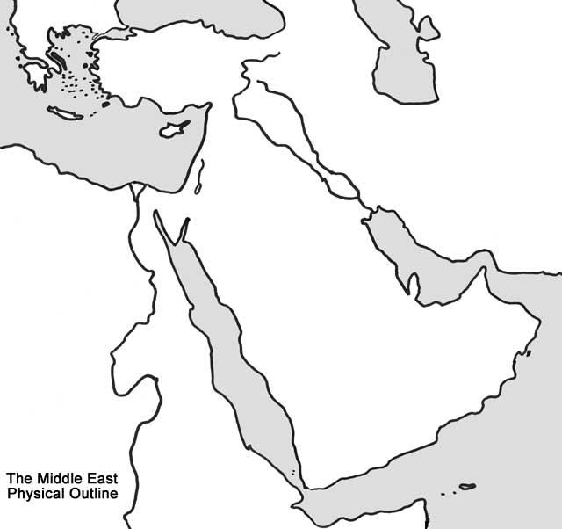
In your groups, divide up the Middle East between your roles (make sure to take each role’s goals into consideration). Label major physical features.

Write a couple sentences describing your division and reasoning behind it.

Name:
Period:
Middle East for the Great Powers

Explain/note down the main points of each primary document

McMahon/Husayn Correspondence | Sykes-Picot Agreement
Balfour Declaration | Article 22 of the Treaty of Versailles

As a group, pick two of the primary documents listed above, and compare and contrast them. How are they similar? Different? Whose goals do they serve? List at least three points.
1.

2.

3.

By yourself, think about how these agreements and maps are different from the ones you came up with last class. Why do you think your solutions are so different from the UK’s and France’s?

Name:
Period:
The Contemporary Middle East

Topic/Issue from class brainstorm:

What did you find out?

Do you think this issue/conflict is related to the geography of the Middle East after WWI? What might be the source of this conflict? Explain.

Peace in the Middle East

At the end of class, we will have a discussion about your perceptions of the Middle East. For 10 minutes, I would like you to write down everything that comes to mind when you think about the Middle East - think of this as a brain dump. If you need prompting, answer this question: Do you think it is ever ok for countries to intervene in other countries’ affairs? Why or why not?

Name:
Period:

Creating a Conflict-Free Middle East

Now that we’ve learned some about the history of the Middle East, it is time for you to create your own map based on your knowledge of the history, demographics, religions, geography, and resources of the Middle East. How would you divide it up? Remember, your goal is the least conflict possible. Be creative!

Your blank map is on the back. You must also write a paragraph describing the reasoning behind your division of the Middle East. Be thorough.

DUE: April 3
POINTS: 30
Remember, this is an individual assignment! All work must be your own.

Be sure to include a legend, major physical features, and country names in your map!

PRIMARY SOURCES FOR READING/HOMEWORK FOR LESSON PLAN 1

No. 1

Translation of a letter from Sharif Husayn of Mecca to Sir Henry McMahon, His Majesty’s High Commissioner at Cairo, July 14, 1915
Whereas the whole of the Arab nation without any exception have decided in these last years to accomplish their freedom, and grasp the reins of their administration both in theory and practice; and whereas they have found and felt that it is in the interest of the Government of Great Britain to support them and aid them in the attainment of their firm and lawful intentions (which are based upon the maintenance of the honour and dignity of their life) without any ulterior motives whatsoever unconnected with this object;
And whereas it is to their (the Arabs') interest also to prefer the assistance of the Government of Great Britain in consideration of their geographic position and economic interests, and also of the attitude of the above-mentioned Government, which is known to both nations and therefore need not be emphasized;
For these reasons the Arab nation sees fit to limit themselves, as time is short, to asking the Government of Great Britain, if it should think fit, for the approval, through her deputy or representative, of the following fundamental propositions, leaving out all things considered secondary in comparison with these, so that it may prepare all means necessary for attaining this noble purpose, until such time as it finds occasion for making the actual negotiations:-
Firstly.- England will acknowledge the independence of the Arab countries, bounded on the north by Mersina and Adana up to the 37th degree of latitude, on which degree fall Birijik, Urfa, Mardin, Midiat, Jezirat (Ibn 'Umar), Amadia, up to the border of Persia; on the east by the borders of Persia up to the Gulf of Basra; on the south by the Indian Ocean, with the exception of the position of Aden to remain as it is; on the west by the Red Sea, the Mediterranean Sea up to Mersina. England to approve the proclamation of an Arab Khalifate of Islam.
Secondly.- The Arab Government of the Sherif will acknowledge that England shall have the preference in all economic enterprises in the Arab countries whenever conditions of enterprises are otherwise equal.
Thirdly.- For the security of this Arab independence and the certainty of such preference of economic enterprises, both high contracting parties will offer mutual assistance, to the best ability of their military and naval forces, to face any foreign Power which may attack either party. Peace not to be decided without agreement of both parties.
Fourthly.- If one of the parties enters into an aggressive conflict, the other party will assume a neutral attitude, and in case of such party wishing the other to join forces, both to meet and discuss the conditions.
Fifthly.- England will acknowledge the abolition of foreign privileges in the Arab countries, and will assist the Government of the Sherif in an International Convention for confirming such abolition.
Sixthly.- Articles 3 and 4 of this treaty will remain in vigour for fifteen years, and, if either wishes it to be renewed, one year's notice before lapse of treaty is to be given.
Consequently, and as the whole of the Arab nation have (praise be to God) agreed and united for the attainment, at all costs and finally, of this noble object, they beg the Government of Great Britain to answer them positively or negatively in a period of thirty days after receiving this intimation; and if this period should lapse before they receive an answer, they reserve to themselves complete freedom of action. Moreover, we (the Sherif's family) will consider ourselves free in work and deed from the bonds of our previous declaration which we made through Ali Effendi.

No. 2

Translation of a letter from McMahon to Husayn, August 30, 1915
To his Highness the Sherif Hussein.
(After compliments and salutations.)
WE have the honour to thank you for your frank expressions of the sincerity of your feeling towards England. We rejoice, moreover, that your Highness and your people are of one opinion-that Arab interests are English interests and English Arab. To this intent 'we confirm to you the terms of Lord Kitchener's message, which reached you by the hand of Ali Effendi, and in which was stated clearly our desire for the independence of Arabia and its inhabitants, together with our approval of the Arab Khalifate when it should be proclaimed. We declare once more that His Majesty's Government would welcome the resumption of the Khalifate by an Arab of true race. With regard to the questions of limits and boundaries, it would appear to be premature to consume our time in discussing such details in the heat of war, and while, in many portions of them, the Turk is up to now in effective occupation; especially as we have learned, with surprise and regret, that some of the Arabs in those very parts, far from assisting us, are neglecting this their supreme opportunity and are lending their arms to the German and the Turk, to the new despoiler and the old oppressor.
Nevertheless, we are ready to send your Highness for the Holy Cities and the noble Arabs the charitable offerings of Egypt so soon as your Highness shall inform us how and where they should be delivered. We are, moreover, arranging for this your messenger to be admitted and helped on any journey he may make to ourselves.
Friendly reassurances. Salutations!
(Signed) A. H. McMAHON.

No. 3

Translation of a letter from Husayn to McMahon, September 9, 1915
WITH great cheerfulness and delight I received your letter dated the 19th Shawal, 1333 (the 30th August, 1915), and have given it great consideration and regard, in spite of the impression I received from it of ambiguity and its tone of coldness and hesitation with regard to our essential point.
It is necessary to make clear to your Excellency our sincerity towards the illustrious British Empire and our confession of preference for it in all cases and matters and under all forms and circumstances. The real interests of the followers of our religion necessitate this.
Nevertheless, your Excellency will pardon me and permit me to say clearly that the coolness and hesitation which you have displayed in the question of the limits and boundaries by saying that the discussion of these at present is of no use and is a loss of time, and that they are still in the hands of the Government which is ruling them, &c., might be taken to infer an estrangement or something of the sort.
As the limits and boundaries demanded are not those of one person whom we should satisfy and with whom we should discuss them after the war is over, but our peoples have seen that the life of their new proposal is bound at least by these limits and their word is united on this.
Therefore, they have found it necessary first to discuss this point with the Power in whom they now have their confidence and trust as a final appeal, viz., the illustrious British Empire.
Their reason for this union and confidence is mutual interest, the necessity of regulating territorial divisions and the feelings of their inhabitants, so that they may know how to base their future and life, so not to meet her (England?) or any of her Allies in opposition to their resolution which would produce a contrary issue, which God forbid.
For the object is, honourable Minister, the truth which is established on a basis which guarantees the essential sources of life in future.
Yet within these limits they have not included places inhabited by a foreign race. It is a vain show of words and titles.
May God have mercy on the Khalifate and comfort Moslems in it.
I am confident that your Excellency will not doubt that it is not I personally who am demanding of these limits which include only our race, but that they are all proposals of the people, who, in short, believe that they are necessary for economic life.
Is this not right, your Excellency the Minister?
In a word, your high Excellency, we are firm in our sincerity and declaring our preference for loyalty towards you, whether you are satisfied with us, as has been said, or angry.
With reference to your remark in your letter above mentioned that some of our people are still doing their utmost in promoting the interests of Turkey, your goodness (lit. "perfectness") would not permit you to make this an excuse for the tone of coldness and hesitation with regard to our demands, demands which I cannot admit that you, as a man of sound opinion, will deny to be necessary for our existence; nay, they are the essential essence of our life, material and moral.
Up to the present moment I am myself with all my might carrying out in my country all things in conformity with the Islamic law, all things which tend to benefit the rest of the Kingdom, and I shall continue to do so until it pleases God to order otherwise.
In order to reassure your Excellency I can declare that the whole country, together with those who you say are submitting themselves to Turco-German orders, are all waiting the result of these negotiations, which are dependent only on your refusal or acceptance of the question of the limits and on your declaration of safeguarding their religion first and then the rest of rights from any harm or danger.
Whatever the illustrious Government of Great Britain finds conformable to its policy on this subject, communicate it to us and specify to us the course we should follow.
In all cases it is only God's will which shall be executed, and it is God who is the real factor in everything.
With regard to our demand for grain for the natives, and the moneys ("surras") known to the Wakfs' Ministry and all other articles sent here with pilgrims' caravans, high Excellency, my intention in this matter is to confirm your proclamations to the whole world, and especially to the Moslem world, that your antagonism is confined only to the party which has usurped the rights of the Khalifate in which are included the rights of all Moslems.
Moreover the said grain is from the special Wakfs and has nothing to do with politics.
If you think it should be, let the grain of the two years be transported in a special steamer to Jedda in an official manner, in the name of all the natives as usual, and the captain of the steamer or the special "Mamur" detailed as usual every year to hand it over on his arrival at the port will send to the Governor of Jedda asking for the Mamur of the grain at Jedda or a responsible official to take over the grain and give the necessary receipt signed by the said Mamur, that is the Mamur of the grain himself. He should make it a condition that he would (? not) accept any receipt but that signed by this Mamur.
Let the captain of the steamer or the "Mamur" (detailed with the grain) be instructed that if he finds anything contrary to this arrangement he should warn them that he will return home with the cargo. Thereupon the Mamur and the special committee detailed with him, which is known as the committee of the grain for the natives, will take over the grain in the proper form.
Please accept my best regards and salutations.
If you choose to send a reply to this, please send it with the bearer. 29th Shawal, 1333.

No. 4

Translation of a letter from McMahon to Husayn, October 24, 1915
I have received your letter of the 29th Shawal, 1333, with much pleasure and your expressions of friendliness and sincerity have given me the greatest satisfaction.
I regret that you should have received from my last letter the impression that I regarded the question of the limits and boundaries with coldness and hesitation; such was not the case, but it appeared to me that the time had not yet come when that question could be discussed in a conclusive manner.
I have realised, however, from your last letter that you regard this question as one of vital and urgent importance. I have, therefore, lost no time in informing the Government of Great Britain of the contents of your letter, and it is with great pleasure that I communicate to you on their behalf the following statement, which I am confident you will receive with satisfaction:-
The two districts of Mersina and Alexandretta and portions of Syria lying to the west of the districts of Damascus, Homs, Hama and Aleppo cannot be said to be purely Arab, and should be excluded from the limits demanded.
With the above modification, and without prejudice of our existing treaties with Arab chiefs, we accept those limits.
As for those regions lying within those frontiers wherein Great Britain is free to act without detriment to the interest of her ally, France, I am empowered in the name of the Government of Great Britain to give the following assurances and make the following reply to your letter:-
1. Subject to the above modifications, Great Britain is prepared to recognize and support the independence of the Arabs in all the regions within the limits demanded by the Sherif of Mecca.
2. Great Britain will guarantee the Holy Places against all external aggression and will recognise their inviolability.
3. When the situation admits, Great Britain will give to the Arabs her advice and will assist them to establish what may appear to be the most suitable forms of government in those various territories.
4. On the other hand, it is understood that the Arabs have decided to seek the advice and guidance of Great Britain only, and that such European advisers and officials as may be required for the formation of a sound form of administration will be British.
5. With regard to the vilayets of Bagdad and Basra, the Arabs will recognise that the established position and interests of Great Britain necessitate special administrative arrangements in order to secure these territories from foreign aggression, to promote the welfare of the local populations and to safeguard our mutual economic interests.
I am convinced that this declaration will assure you beyond all possible doubt of the sympathy of Great Britain towards the aspirations of her friends the Arabs and will result in a firm and lasting alliance, the immediate results of which will be the expulsion of the Turks from the Arab countries and the freeing of the Arab peoples from the Turkish yoke, which for so many years has pressed heavily upon them.
I have confined myself in this letter to the more vital and important questions, and if there are any other matters dealt with in your letter which I have omitted to mention, we may discuss them at some convenient date in the future.
It was with very great relief and satisfaction that I heard of the safe arrival of the Holy Carpet and the accompanying offerings which, thanks to the clearness of your directions and the excellence of your arrangements, were landed without trouble or mishap in spite of the dangers and difficulties occasioned by the present sad war. May God soon bring a lasting peace and freedom to all peoples!
I am sending this letter by the hand of your trusted and excellent messenger, Sheikh Mohammed Ibn Arif Ibn Uraifan, and he will inform you of the various matters of interest, but of less vital importance, which I have not mentioned in this letter.
(Compliments)
(Signed) A. H. McMAHON.

https://www.jewishvirtuallibrary.org/jsource/History/hussmac1.html

The Sykes-Picot Agreement : 1916
It is accordingly understood between the French and British governments:
That France and Great Britain are prepared to recognize and protect an independent Arab states or a confederation of Arab states (a) and (b) marked on the annexed map, under the suzerainty of an Arab chief. That in area (a) France, and in area (b) Great Britain, shall have priority of right of enterprise and local loans. That in area (a) France, and in area (b) Great Britain, shall alone supply advisers or foreign functionaries at the request of the Arab state or confederation of Arab states.
That in the blue area France, and in the red area Great Britain, shall be allowed to establish such direct or indirect administration or control as they desire and as they may think fit to arrange with the Arab state or confederation of Arab states.
That in the brown area there shall be established an international administration, the form of which is to be decided upon after consultation with Russia, and subsequently in consultation with the other allies, and the representatives of the Shereef of Mecca.
That Great Britain be accorded (1) the ports of Haifa and Acre, (2) guarantee of a given supply of water from the Tigres and Euphrates in area (a) for area (b). His Majesty's government, on their part, undertake that they will at no time enter into negotiations for the cession of Cyprus to any third power without the previous consent of the French government.
That Alexandretta shall be a free port as regards the trade of the British empire, and that there shall be no discrimination in port charges or facilities as regards British shipping and British goods; that there shall be freedom of transit for British goods through Alexandretta and by railway through the blue area, or (b) area, or area (a); and there shall be no discrimination, direct or indirect, against British goods on any railway or against British goods or ships at any port serving the areas mentioned.
That Haifa shall be a free port as regards the trade of France, her dominions and protectorates, and there shall be no discrimination in port charges or facilities as regards French shipping and French goods. There shall be freedom of transit for French goods through Haifa and by the British railway through the brown area, whether those goods are intended for or originate in the blue area, area (a), or area (b), and there shall be no discrimination, direct or indirect, against French goods on any railway, or against French goods or ships at any port serving the areas mentioned.
That in area (a) the Baghdad railway shall not be extended southwards beyond Mosul, and in area (b) northwards beyond Samarra, until a railway connecting Baghdad and Aleppo via the Euphrates valley has been completed, and then only with the concurrence of the two governments.
That Great Britain has the right to build, administer, and be sole owner of a railway connecting Haifa with area (b), and shall have a perpetual right to transport troops along such a line at all times. It is to be understood by both governments that this railway is to facilitate the connection of Baghdad with Haifa by rail, and it is further understood that, if the engineering difficulties and expense entailed by keeping this connecting line in the brown area only make the project unfeasible, that the French government shall be prepared to consider that the line in question may also traverse the Polgon Banias Keis Marib Salkhad tell Otsda Mesmie before reaching area (b).
For a period of twenty years the existing Turkish customs tariff shall remain in force throughout the whole of the blue and red areas, as well as in areas (a) and (b), and no increase in the rates of duty or conversions from ad valorem to specific rates shall be made except by agreement between the two powers.
There shall be no interior customs barriers between any of the above mentioned areas. The customs duties leviable on goods destined for the interior shall be collected at the port of entry and handed over to the administration of the area of destination.
It shall be agreed that the French government will at no time enter into any negotiations for the cession of their rights and will not cede such rights in the blue area to any third power, except the Arab state or confederation of Arab states, without the previous agreement of his majesty's government, who, on their part, will give a similar undertaking to the French government regarding the red area.
The British and French government, as the protectors of the Arab state, shall agree that they will not themselves acquire and will not consent to a third power acquiring territorial possessions in the Arabian peninsula, nor consent to a third power installing a naval base either on the east coast, or on the islands, of the red sea. This, however, shall not prevent such adjustment of the Aden frontier as may be necessary in consequence of recent Turkish aggression.
The negotiations with the Arabs as to the boundaries of the Arab states shall be continued through the same channel as heretofore on behalf of the two powers.
It is agreed that measures to control the importation of arms into the Arab territories will be considered by the two governments.
I have further the honor to state that, in order to make the agreement complete, his majesty's government are proposing to the Russian government to exchange notes analogous to those exchanged by the latter and your excellency's government on the 26th April last. Copies of these notes will be communicated to your excellency as soon as exchanged.I would also venture to remind your excellency that the conclusion of the present agreement raises, for practical consideration, the question of claims of Italy to a share in any partition or rearrangement of turkey in Asia, as formulated in article 9 of the agreement of the 26th April, 1915, between Italy and the allies.
His Majesty's government further consider that the Japanese government should be informed of the arrangements now concluded.

http://avalon.law.yale.edu/20th_century/sykes.asp

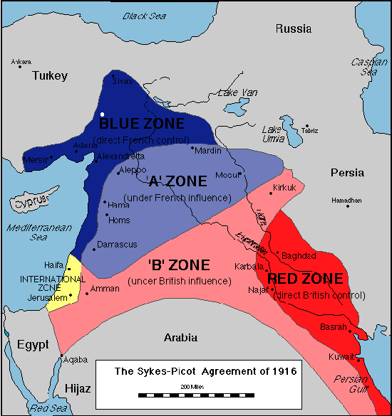
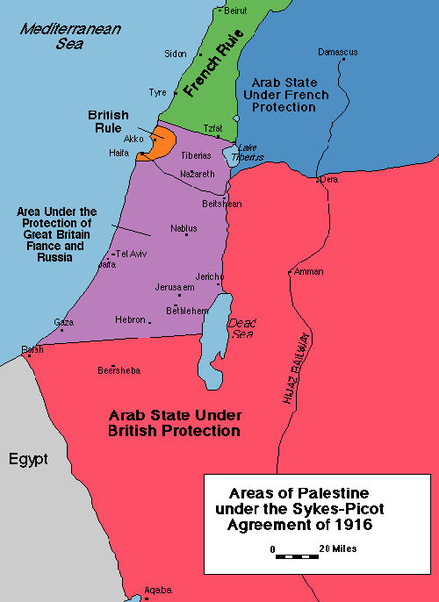

Balfour Declaration 1917
November 2nd, 1917
Dear Lord Rothschild,
I have much pleasure in conveying to you, on behalf of His Majesty's Government, the following declaration of sympathy with Jewish Zionist aspirations which has been submitted to, and approved by, the Cabinet.
"His Majesty's Government view with favour the establishment in Palestine of a national home for the Jewish people, and will use their best endeavours to facilitate the achievement of this object, it being clearly understood that nothing shall be done which may prejudice the civil and religious rights of existing non-Jewish communities in Palestine, or the rights and political status enjoyed by Jews in any other country."
I should be grateful if you would bring this declaration to the knowledge of the Zionist Federation.
Yours sincerely,
Arthur James Balfour

http://avalon.law.yale.edu/20th_century/balfour.asp

ARTICLE 22. [of the Treaty of Versailles/Covenant of the League of Nations]
To those colonies and territories which as a consequence of the late war have ceased to be under the sovereignty of the States which formerly governed them and which are inhabited by peoples not yet able to stand by themselves under the strenuous conditions of the modern world, there should be applied the principle that the well-being and development of such peoples form a sacred trust of civilisation and that securities for the performance of this trust should be embodied in this Covenant. The best method of giving practical effect to this principle is that the tutelage of such peoples should be entrusted to advanced nations who by reason of their resources, their experience or their geographical position can best undertake this responsibility, and who are willing to accept it, and that this tutelage should be exercised by them as Mandatories on behalf of the League. The character of the mandate must differ according to the stage of the development of the people, the geographical situation of the territory, its economic conditions, and other similar circumstances. Certain communities formerly belonging to the Turkish Empire have reached a stage of development where their existence as independent nations can be provisionally recognised subject to the rendering of administrative advice and assistance by a Mandatory until such time as they are able to stand alone. The wishes of these communities must be a principal consideration in the selection of the Mandatory. Other peoples, especially those of Central Africa, are at such a stage that the Mandatory must be responsible for the administration of the territory under conditions which will guarantee freedom of conscience and religion, subject only to the maintenance of public order and morals, the prohibition of abuses such as the slave trade, the arms traffic, and the liquor traffic, and the prevention of the establishment of fortifications or military and naval bases and of military training of the natives for other than police purposes and the defence of territory, and will also secure equal opportunities for the trade and commerce of other Members of the League....In every case of mandate, the Mandatory shall render to the Council an annual report in reference to the territory committed to its charge. The degree of authority, control, or administration to be exercised by the Mandatory shall, if not previously agreed upon by the Members of the League, be explicitly defined in each case by the Council. A permanent Commission shall be constituted to receive and examine the annual reports of the Mandatories and to advise the Council on all matters relating to the observance of the mandates.

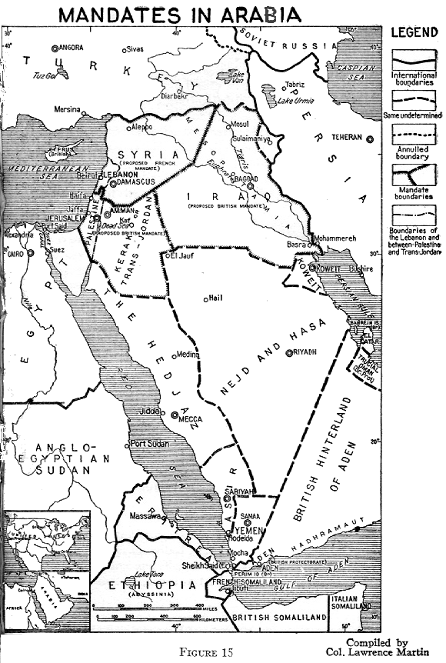

http://net.lib.byu.edu/~rdh7/wwi/versailles.html

