The Amman Citadel
Arrival Orientation – Amman Exploration Activity
Overview
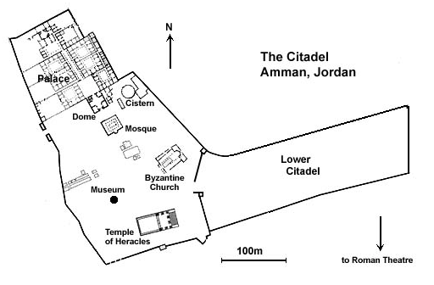
Students will visit the Amman Citadel, a historic site in downtown Amman that rests on one of the seven jabals that originally made up Amman. The Citadel is important because of its history being occupied during many periods including that of the Romans, Byzantines, and Umayyads. The major buildings on the site of the Temple of Hercules, a Byzantine church, and the Umayyad Palace. Archaeologists have been working on the site since the 1920s, including the British, Italian, French, Spanish and Jordanian projects; however, a great deal of the Citadel remains unexcavated.
Background Information: The Hill of the Citadel was occupied as early as the Neolithic Period, and fortified during the Bronze Age (1800 BC). The ruins on the hill are Roman through early Islamic. During the Iron Age, the Citadel was called Rabboth-Ammon. The Amman Citadel Inscription comes from this period, an example of early Phoenician writing. It came to be occupied by the Assyrians, Babylonians, and Persians. When conquered by the Greeks in 331 BC, the city was renamed Philadelphia. From the Hellenistic Period, there were not many architectural changes. The Citadel came under Roman rule in 30 BC and finally under Muslim rule in AD 661. The Citadel declined in importance under Ayyubid rule in the 13th century, but a watchtower was added to the site during this period.

There are several sites with the Citadel Archaeological Park:

Temple of Hercules: Built between 162-166 AD. Larger than any temple in Rome itself, the massive structure faces east. The temple portico is framed by six 33-foot tall columns. The absence of columns on the rest of the structure has convinced the excavator that the temple was actually unfinished. The temple is 31m long by 26m wide.

Byzantine Church: Constructed in the 5th-6th centuries AD, its nave is flanked by two rows of columns.

Governor’s Palace and Mosque: This was the Ummayyad Governor’s palace (8th century). The dome is a modern reconstruction that gives the building an odd, Pac-Man like appearance.

Cistern: Located to the right of the vestibule, this large cistern was the primary water supply to the governor’s palace. At 5m deep and 16m in diameter, it would have held just over 1,000 cubic meters or approximately 250,000 gallons of water. The cistern was fed by rainwater through an inlet channel, and could be entered for maintenance by the stairs. A column measured the water level.
The Jordan Archaeological Museum is also located in the Citadel complex as well. Built in 1951, it presents artifacts from archaeological sites in Jordan, dating form the 15th century. The collections are arranged in chronological order and include items of everyday life such as flint, glass, metal and pottery objects, as well as more artistic items such as jewelry and statues. The museum also includes a coin collection. The museum houses the Ain Ghazal statues, which are among the oldest statues ever made by a human civilization. The museum formerly housed some of the Dead Sea Scrolls, including the only copper scroll, which are now on display in the newly established Jordan Museum.

