ottoman art experience Lesson Plan/Agenda

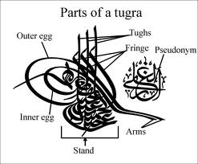

Lesson Summary: This lesson introduces aspects of Ottoman art and its connections to representative art, as well as to the role of art in society.
Time Allotted: 2 periods
Driving Question/Essential Question: What role did art play in the culture and history of the Ottoman Empire? What messages would rulers send through the use of their personal signs?
Primary Focus: To help students develop an understanding of the messages and relevance of how messages have been and can be conveyed through art.
Contemporary Issue: By comparing Ottoman sultans to contemporary world leaders, students will consider the role and importance of images, of words both written and spoken, as well as the attributes that citizens may find desirable in leaders. Students will draw parallels between calligraphy and modern urban graffiti. Possible historical tie-ins may include [but not limited to] the John Hancock signature on the Declaration of Independence, the Boston Massacre “Bloody Massacre” engraving by Paul Revere, “Uncle Sam Wants You!” and other propaganda posters, as well as any number of iconic modern brand name advertisements (McDonalds arches, provided herein.).
Teacher Rationale: The Ottoman Empire played a pivotal role in the development of the Middle East, Europe, Africa, and Asia. At its peak, their territory and culture spanned three continents, from which they drew a treasury of artistic elements and inspirations. Students will be greatly enriched by studying the art of this period. By investigating the Ottoman Empire, students will be learning their unique history and contributions to art through the use of a critical analysis of their artwork, specifically the tugra. Along with analyzing the artwork, students would be tasked with engaging in critical thinking, using literacy and art-rich document analysis to further and heighten their appreciation of the critical role the Ottomans and their legacy. Students will additionally be contrasting and comparing the enclosed artwork to other iconic imagery.
Thematic Subjects: Art History, World History

NY State Social Studies Standards:
- NYS SS2: Students will use a variety of intellectual skills to demonstrate their understanding of major ideas, eras, themes, developments, and turning points in world history and examine the broad sweep of history from a variety of perspectives.

NYS SS5: Civics, Citizenship, and Government - use a variety of intellectual skills to demonstrate their understanding of the necessity for establishing governments; the governmental system of the U.S. and other nations; the U.S. Constitution; the basic civic values of American constitutional democracy; and the roles, rights, and responsibilities of citizenship, including avenues of participation.
Common Core Learning Standards in Literacy in History/Social Studies:
- RH6-8.2 – Determine the central ideas or information of a primary or secondary source; provide an accurate summary of the source distinct from prior knowledge or opinions.
- RH6-8.1 – Cite textual evidence to support analysis of primary and secondary sources
- WHST6-8.2 – Write informative text, including the narration of historical text
- RH.6-8.6 - Identify aspects of a text that reveal an author’s point of view or purpose (e.g., loaded language, inclusion or avoidance of particular facts).
- RH.6-8.7 - Integrate visual information (e.g., in charts, graphs, photographs, videos, or maps) with other information in print and digital texts.
- RH.9-10.9. Compare and contrast treatments of the same topic in several primary and secondary sources.
- RH.9-10.7 Integrate quantitative or technical analysis (e.g., charts, research data) with qualitative analysis in print or digital text.
- SL.9-10.1. Initiate and participate effectively in a range of collaborative discussions (one-on-one, in groups, and teacher-led) with diverse partners on grades 9-10 topics, texts, and issues, building on others’ ideas and expressing their own clearly and persuasively.
- SL.9-10.1.C. Propel conversations by posing and responding to questions that relate the current discussion to broader themes or larger ideas; actively incorporate others into the discussion; and clarify, verify, or challenge ideas and conclusions.
- RH.11-12.1 - Cite specific textual evidence to support analysis of primary and secondary sources, connecting insights gained from specific details to an understanding of the text as a whole.
- RH.11-12.2 - Determine the central ideas or information of a primary or secondary source; provide an accurate summary that makes clear the relationships among the key details and ideas.
NYC Social Studies Practices and Historical Thinking Skills:
- 9-12:A. Gathering, Interpreting, and Using Evidence: 2. Identify, describe, and evaluate evidence about events from diverse sources (including written documents, works of art, photographs, charts and graphs, artifacts, oral traditions, and other primary and secondary sources)
- 9-12:A. Gathering, Interpreting, and Using Evidence: 5. Make inferences and draw conclusions from evidence.
- 9-12:C. Comparison and Contextualization: 3. Identify and compare similarities and differences between historical developments over time and in different geographical and cultural contexts.
- 9-12:C. Comparison and Contextualization: 4. Describe, compare, and evaluate multiple historical developments (within societies; across and between societies; in various chronological and geographical contexts).
New York State Scope and Sequence:
Essential Question: What sustains an empire?
Inquiry Question 9.3.5: What factors contributed to the longevity of the Ottoman Empire? What factors threatened Ottoman hegemony? The Impact of the Ottoman Empire on the Middle East and Europe (1281 – 1571 C.E.) 9.7c ■ Human and physical geography (Mediterranean Sea, Black Sea, Red Sea, Constantinople) ■ Suleiman I (the Magnificent, the Lawgiver), sultans, Topkapi, the Blue Mosque ■ Ethnic and religious composition ■ Structure of family life ■ Interaction with Europe
Inquiry Question: 9.7: The Ottoman Empire And The Ming Dynasty Pre- 1600: Islam, Neo-Confucianism, and Christianity each influenced the development of regions and shaped key centers of power in the world between 1368 and 1683. The Ottoman Empire and the Ming Dynasty were two powerful states, each with a view of itself and its place in the world. (Standards 2, 3, 4, 5) ■ Influence of Islam on Ottoman political and societal organization
Depth of Knowledge: 2 (Skill/Concept), 3 (Strategic Thinking), 4 (Extended Thinking).
New York Art Standards:

Standard 3 - Responding To and Analyzing Works of Art : Visual Art: Key idea: Students will reflect on, interpret, and evaluate works of art, using the language of art criticism. Students will analyze the visual characteristics of the natural and built environment and explain the social, cultural, psychological, and environmental dimensions of the visual arts. Students will compare the ways in which a variety of ideas, themes, and concepts are expressed through the visual arts with the ways they are expressed in other disciplines.

Standard 4 - Understanding The Cultural Dimensions and Contributions of The Arts: Visual Arts: Key idea: Students will explore art and artifacts from various historical periods and world cultures to discover the roles that art plays in the lives of people of a given time and place and to understand how the time and place influence the visual characteristics of the art work. Students will explore art to understand the social, cultural, and environmental dimensions of human society.
National Council of Teachers of English (NCTE) and International Reading Association (IRA) standards:
- Students apply a wide range of strategies to comprehend, interpret, evaluate, and appreciate texts. They draw on their prior experience, their interactions with other readers and writers, their knowledge of word meaning and of other texts, their word identification strategies, and their understanding of textual features (e.g., sound-letter correspondence, sentence structure, context, graphics).
- Students adjust their use of spoken, written, and visual language (e.g., conventions, style, vocabulary) to communicate effectively with a variety of audiences and for different purposes.
- Students employ a wide range of strategies as they write and use different writing process elements appropriately to communicate with different audiences for a variety of purposes.
- Students conduct research on issues and interests by generating ideas and questions, and by posing problems. They gather, evaluate, and synthesize data from a variety of sources (e.g., print and non-print texts, artifacts, people) to communicate their discoveries in ways that suit their purpose and audience.
- Students use a variety of technological and information resources (e.g., libraries, databases, computer networks, video) to gather and synthesize information and to create and communicate knowledge.
- Students develop an understanding of and respect for diversity in language use, patterns, and dialects across cultures, ethnic groups, geographic regions, and social roles.
- Students use spoken, written, and visual language to accomplish their own purposes (e.g., for learning, enjoyment, persuasion, and the exchange of information).
Content Goal:
- Students will learn about the relevance and role of art in the Ottoman Empire;
- Students will analyze textual and image primary and secondary sources;
- Students will infer on the social importance of these images in Ottoman society;
- Students will develop content-related questions and answer them.
Prerequisites: This lesson follows previous discussions and lessons on the Ottoman Empire.
Charlotte Danielson Model Sections 3B, 3D Discussion Stems and Starters:
- What is the definition of empire?
- What is the definition of calligraphy?
- What are some reasons people choose to make their writing more elegant and expressive?
- What is the benefit making your writing more elegant and expressive?
- What are the pros and cons of calligraphy?
- What are the pros and cons of images being used over the written word?
- what would a new sultan seek to convey to his population? To other countries?
- When would a formal signature be used by a head of state?
- What are the drawbacks of having a picture tell a story?
- What are some of the messages conveyed by graffiti today?
- What would be the likely outcomes of our President starting to use a tugra instead of a signature in formal settings?
Social Studies Skills Goal: inferring information, analyzing text, analyzing images.
Learning Objectives: Individually (or in pairs) and in groups, at the completion of this lesson, students will know what impact the tugra held to the Ottoman people, and what role images and perceptions of them play to various audiences across eras.
Formal Assessment Tool(s): Informal assessment, conference and small group monitoring, formal written exit slips, participation, creation of individually produced materials inspired by Ottoman Empire artwork.
Teacher Designed Standards Assessed: Students’ work will reflect their progress as young historians/students by:
- Analysis of primary and secondary sources;
- Synthesizing original material based on teacher-provided examples;
- Critically evaluating the work of others;
- Formulating a point of view to develop critical thinking.
Word Bank: posted on WordWall, handout of Vocabulary In Context: tugra, calligraphy, sultan, signature, graffiti, Ottoman, empire, pseudonym.
Warm Up: Turn and Talk: What does the quote on the board mean? Justify your answer.
Writing Prompt:
- Students will respond to a quote posted by teacher as WarmUp,
- Students will develop content-related questions and answer them,
- Students will respond to signatures as entry points,
- Students will create their own written work in the form of a tugra,
- Students will complete Exit Slip Reflections and Connection.

differentiated groups | class 1 | class 2 | class 3 | class 4 | class 5
Blue
Green
Red

Materials: to engage in this activity, students will require:
- large print Warm Up quote and answer slips
- color tugra elements poster
- colored pens or pencils, blank paper
- examples of Islamic writing
- post-it notes
Language Goal: using causal words (because of, due to, leading to); descriptive language.
Higher Order Thinking Skill Question: Why was this type of art created? What do you believe was the meaning and symbolism of the artwork at its time? What message do you believe that artist was trying to impart? What does the art teach you about the people and their time period?
Mini-Lesson: How can young historians cite textual evidence and integrate visual evidence in order to examine the role of art in the Ottoman Empire by analyzing primary and secondary sources?
Quick Check: Student responsiveness will be gauged as they respond to questions posed throughout introduction to see what connections they are making to their prior knowledge.
Work Period: Individually and in groups, students will:
Task 1: Listen and Learn – teacher intro to topic of art of the Ottoman Empire;
Task 2: Analyze – Historical artwork and text to determine meaning and function;
Task 3: Evaluate – Effects of calligraphy and tugras on a leader’s image;
Task 4: Apply – Create their own historically-inspired artwork.
Share Out: Students display their original work and discuss its cultivation, formulate opinions.
Closing: Attempt to answer H.O.T.S. question, in whole or in part. Why does our current president not use a tugra?
Development/Procedure:
Lesson 1:
- Warm Up: teacher posts quote and distributes group answer slips. Groups of students respond to quote in writing. Teacher collects and reads group answers aloud. Teacher gauges pulse of class as to prior knowledge, association.
- Teacher distributes first set of index cards to student groups, tasks students in groups to write their own signatures on cards. Teacher collects cards and has students point out personal observations about irregularities and individual flourishes.
- Teacher then leads a discussion on role of images, signage, and signatures as a way of conveying messages, and of the role it would have to a statesman, and to public.
- Teacher introduces tugra, the seal or signature of an Ottoman sultan that was affixed to all official documents and correspondence. It was also carved on his seal and stamped on the coins minted during his reign. Very elaborate decorated versions were created for important documents that were also works of art in the traditional Ottoman style.
- Teacher directs the students to examine the tugra handouts, and discusses its symbolism and its elements. Students make inferences and form impressions.
  - I have enclosed for you the parts of a tugra. A tugra was a symbol that sultans would use to indicate their names. It was based on the Ottomans’ appreciation and talent for calligraphy. It would have some letters and designs that represented the sultan and his father.
  - The tughra has a characteristic form, two loops on the left side, three vertical lines in the middle, stacked writing on the bottom and two extensions to the right. Each of these elements has a specific meaning, and together they make up the form that is easily recognizable as a tughra.
  - the parts of a tugra include the stand, the eggs, the tughs, and the arms, as well as a pseudonym to guide the audience into understanding the importance of the sultan.
  - the stand, or the base of the tugra would include the main text, such as the name of the sultan, the name of his father, the honorable titles the sultan held, and the prayer “ever victorious.”
  - the eggs would be two curves on the left side of the tugra that would make the name more appealing and eye-catching. The eggs are supposed to symbolize the two seas the sultans held sway over: the outer larger loop signifying the Mediterranean and the inner, smaller loop signifying the Black Sea.
  - the tughs are the three extensions at the upper part. Sometimes these could be a letter in Arabic, but are usually meant to represent flag staffs. They signify independence. The S-shaped lines crossing the tugs signify that the winds blow from the east to the west, the traditional movement of the Ottomans.
  - the arms are the two parallel lines starting from the eggs and running to the right side of the tugra, and signify a sword, symbol of power and might.
  - In some tugras, the arms point to the pseudonym of the sultan in the upper right area. A pseudonym is a made-up that brings fame or reputation to a person. For example, who knows the name of the rapper Eminem? He is also known as Marshall Mathers, and also as Slim Shady. Why does he use these other names? what does he hope to achieve from the audience?
- Teacher explains that these images were created in context of Muslim prohibitions and rules against portraying animated beings, http://www.islamicacademy.org/html/Articles/English/Picutres_in_Islam.htm
- As a result, the reliance on the written word and eventually calligraphy was the standard. This type of writing was paramount and central to the sultans of the Ottoman empire during this time.
- Quick Check: Student responsiveness will be gauged as they respond to questions posed throughout introduction to see what connections they are making to their prior knowledge.
- Teacher asks: “If you were a leader at a time when your people could not see you or hear from you, how would you convey your messages to them, as well as to other countries? How would you use art that contains no images of beings, but still transmits a strong message?” Teacher reminds class that they would not be seen as a leader, that the tugra is all that their people would know of them.
- Teacher then models first letter/first letter (or first letter/last letter) model of the tugra [John Smith, or John Smith], asks students “Which do you think would be more important, your given or your family name? How would you arrange your name to convey messages of strength? of wisdom? of kindness?”
- Teacher asks class what other possible characteristics a leader would wish to include?
- HW: Recreation and Application: compose your own tugra for tomorrow, to be shared out before the class.

Lesson 2:
- Warm Up: Teacher distributes Compare Two Quotes document for analysis.
- As the students are completing their document, teacher collects homework of student-created tugras, and places them on a wall or walls around the classroom for a gallery walk.
- Gallery Walk: Students are told that they will have the duration of two songs, The Four Lads “Istanbul” and They Might Be Giants “Istanbul” to complete their gallery walks.
- Teacher distributes post-it notes to students, and tasks them to write down their observations as to their impressions of the tugras regarding their uniqueness, and perceived message they send, and stick their notes next to the tugras.
- Students return to their seats to generate a Quick-Write in the provided graphic organizer.
- Quick Check: Student responsiveness will be gauged as they respond to questions posed throughout introduction to see what connections they are making to their prior knowledge.
- Teacher begins to display relevant images on overhead projector or Smart Board from the files and/or Metropolitan Museum of Art collections pertaining to the Ottomans.
- Teacher collects Quick-Write organizers and turns the discussion to a modern-day application of this concept. Teacher directs students groups to McDonalds and Nike logos, and asks students about their meanings. Teacher displays modern graffiti, and asks students what messages are being sent by the artist, using this medium.
- Teacher then tasks student groups to create a modern-day tugra for their choice of subject. Choices may include
  - their school
  - their favorite sports team
  - their city
  - the current president
- Teacher will remind student groups of the elements they saw in prior tugras, and that they should begin their work by deciding which three symbols they will make central.
- Student groups will utilize classroom time to complete their tasks.
- HW: Reflection and Conclusion: Students will write an EXIT SLIP on their experience of creating a tugra.

Differentiation/Modification: An engaging and interactive introduction will be given to the class as a whole. The introduction will also include visual components so that students who need visual stimuli will be engaged. ELL/IEP/FELL students will receive a Vocabulary in Context. Students will receive differentiated art work samples according to skill level evidenced by pretest to unit. Teacher will instruct selected special-focus group, as dictated by Prosper/IEP/baseline exams. Grouping and placement based upon Prosper skills assessments, behavioral needs, linguistic needs, prior baselines, and IEP goals. Varying academic levels: uses group time to allow students to progress at their own ability level. Visual learners: incorporates graphic organizers to help structure responses, identify structure. Auditory learners: encourages small-group discussion to create notes for information.
Homework:
#1: Recreation and Application: Based upon the information provided and what you have learned today about the role of art in the Ottoman world, create your own tugra. Include your name, the names of your family or friendship group, or of your city of birth. Write your actual name and school heading on the back of the paper.
#2: Reflection and Conclusion: Students will write an EXIT SLIP on their experience of creating a tugra. Students can use the following prompts to help them write their reflection: What were your feelings before, during, and after the activity? What was the hardest/easiest thing about creating a family tugra? How did you feel being asked to represent your family? What did you learn from this activity? If you had more time, what elements or designs would you add to your tugra? What do you feel your tugra says about you? If you could advise a world leader on creating their own tugra, what advice would you give them? Would a tugra for a modern leader be as important now as it was to the Ottomans?
Students will also complete their Compare Two Quotes graphic organizers.
Extension Activities:
- Classroom Geography: Visually identify connections students have to other countries of the Ottoman Empire. Display a large map of the world. Have each student fill in with a colored marker areas to represent a country or region of the Ottoman Empire. Take time to discuss the finished map.
- Hall of Fame: Invite the class to create a Hall of Fame of most relevant and famous sultans of the Ottoman Empire, who have made important contributions to the history of the Ottomans. Each student should provide a picture or other likeness of the person, identify his birthplace, and explain in a paragraph his accomplishments.
- Trading Cards: Students will research and investigate individual influential sultans, such as Sultan Abdul and Sultan Ahmed. They will transform their research into baseball-type cards containing pertinent relevant information about these historical figures. Information may include lineage, birthplace, years of life, years of reign, major achievements, etc.
Sources:
- Abdul Hamid II Collection: http://www.loc.gov/pictures/search/?st=grid&co=ahii
- Early history: Ch. 2 from Quataert, Donald, The Ottoman Empire 1700-1922, NY: Cambridge Univ. Press, 2000 (Scholarly Readers)
- Later History: sec of ch. 25 from Goodwin, Jason, Lords of the Horizons: A History of the Ottoman Empire, NY: H. Holt, 1999 (General Readers/Adult)
- Letter of Süleyman the Magnificent to Francis I, King of France, Istanbul, 1536, Manuscripts Department, Oriental Section, Supplément turc, 822, Scroll: http://www.loc.gov/exhibits/bnf/bnf0004.html
- LoC source for Suleyman tughra: http://www.loc.gov/exhibits/bnf/images/bnf067.jpg
- Teacher's Guides and Analysis Tools: http://www.loc.gov/teachers/usingprimarysources/guides.html
- The Metropolitan Museum of Art, www.metmuseum.org
Small Group/Individual Conferencing:
Class: Student: Reason:

Notes/Reflections:

exit slip: Reflection and Conclusion:
Students will write an EXIT SLIP on their experience of creating a tugra. Students can use the following prompts to help them write their reflection:

- What were your feelings before, during, and after the activity?
- What was the hardest/easiest thing about creating a family tugra?
- How did you feel being asked to represent your family?
- What did you learn from this activity?
- If you had more time, what elements or designs would you add to your tugra?
- What do you feel your tugra says about you?
- If you could advise a world leader on creating their own tugra, what advice would you give them?
- Would a tugra for a modern leader be as important now as it was to the Ottomans?
_______________________________________________________________________________________________________
exit slip: Reflection and Conclusion:
Students will write an EXIT SLIP on their experience of creating a tugra. Students can use the following prompts to help them write their reflection:

- What were your feelings before, during, and after the activity?
- What was the hardest/easiest thing about creating a family tugra?
- How did you feel being asked to represent your family?
- What did you learn from this activity?
- If you had more time, what elements or designs would you add to your tugra?
- What do you feel your tugra says about you?
- If you could advise a world leader on creating their own tugra, what advice would you give them?
- Would a tugra for a modern leader be as important now as it was to the Ottomans?
Warm Up: Turn and Talk: What does the quote on the board mean? Justify your answer.

Warm Up: Turn and Talk: What does the quote on the board mean? Justify your answer.

Warm Up: Turn and Talk: What does the quote on the board mean? Justify your answer.

Warm Up: Turn and Talk: What does the quote on the board mean? Justify your answer.

Warm Up: Turn and Talk: What does the quote on the board mean? Justify your answer.

Warm Up: Turn and Talk: What does the quote on the board mean? Justify your answer.

Warm Up: Turn and Talk: What does the quote on the board mean? Justify your answer.

Warm Up: Turn and Talk: What does the quote on the board mean? Justify your answer.

"Every picture is an idea. A picture can inspire political and emotional meanings which cannot be conveyed by an article of a hundred pages.”
    - Sultan Abdul Hamid II
( “Ottoman Photography of the Late Nineteenth Century: An ‘Innocent’ Modernism?” Wendy M. K. Shaw)

Vocabulary in Context
calligraphy:
empire:
graffiti:
Ottoman:
pseudonym:
signature:
sultan:
tugra:
Vocabulary in Context
calligraphy:
empire:
graffiti:
Ottoman:
pseudonym:
signature:
sultan:
tugra:

Vocabulary in Context
calligraphy: The art of fine handwriting.
empire: A political unit having a large territory or a number of territories or nations, and ruled by a single supreme authority.
graffiti: inscriptions or drawings scratched or carved onto a surface
Ottoman: Of or relating to the Ottoman Empire or its people, language, or culture.
pseudonym: A fictitious name, especially a pen name.
signature: A distinctive mark, characteristic, or sound indicating identity
sultan: A ruler of a Muslim country, especially of the former Ottoman Empire.
tugra: A signature or seal of an Ottoman sultan that was affixed to all official documents and correspondence.

Vocabulary in Context
calligraphy: The art of fine handwriting.
empire: A political unit having a large territory or a number of territories or nations, and ruled by a single supreme authority.
graffiti: inscriptions or drawings scratched or carved onto a surface
Ottoman: Of or relating to the Ottoman Empire or its people, language, or culture.
pseudonym: A fictitious name, especially a pen name.
signature: A distinctive mark, characteristic, or sound indicating identity
sultan: A ruler of a Muslim country, especially of the former Ottoman Empire.
tugra: A signature or seal of an Ottoman sultan that was affixed to all official documents and correspondence.

comparing two quotes:
"Every picture is an idea. A picture can inspire political and emotional meanings which cannot be conveyed by an article of a hundred pages.”  - Sultan Abdul Hamid II | “The albums are ‘presented by Sultan to Her Majesty’s Government for the use of the British public in order that it should be generally known in England what progress has been made in literature and in science in Turkey, since His Majesty came to the throne, and to show how greatly he is interested in the advancement of learning and education in his Empire’.”  - British Ambassador to the Ottoman Empire P. Currie in reference to albums of photographs presented to the British Library in 1893.
Source: “Ottoman Photography of the Late Nineteenth Century: An ‘Innocent’ Modernism?” Wendy M. K. Shaw | Source: Shaw, Wendy M.K. Possessors and Possessed: Museums, Archaeology, and the Visualization of History of the Late Ottoman Empire, Univ. of California Press, 2003, pp. 143-144

  - What does the Sultan believe to be the role and impact of images? Explain your answer.
  - What does the Ambassador believe to be the role and impact of images? Explain your answer.
  - What do you think could be the cause of the difference between the European and Ottoman perceptions? Explain your answer.
  - Which quote do you think happened first? Explain your answer.
  - Which do you think – image or text - would be able to reach the greater audience during the Ottomans time? Explain your answer.
  - Which do you think – image or text - Which do you think – image or text - would be able to reach the greater audience during our time? Explain your answer.
gallery walk quick-write sheet

- What are five observations that you noticed on your gallery walk?
- What do you think you did differently in your tugra from other people in your class?
- What was the easiest part for you in creating your tugra yesterday?
- What was the hardest part for you in creating your tugra?
- How do the class tugras differ from the tugra you saw of the sultan?
- Now that you have seen others’, what would you like to be able to add to your own tugra?
- How would you edit (take away or change) something in your tugra?

gallery walk quick-write sheet

- What are five observations that you noticed on your gallery walk?
- What do you think you did differently in your tugra from other people in your class?
- What was the easiest part for you in creating your tugra yesterday?
- What was the hardest part for you in creating your tugra?
- How do the class tugras differ from the tugra you saw of the sultan?
- Now that you have seen others’, what would you like to be able to add to your own tugra?
- How would you edit (take away or change) something in your tugra?
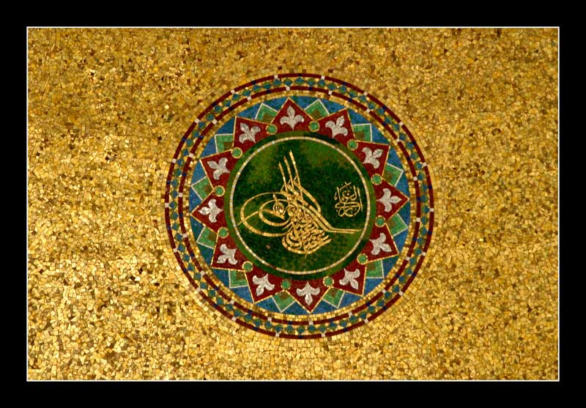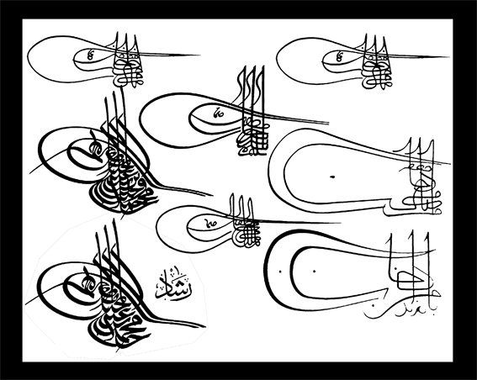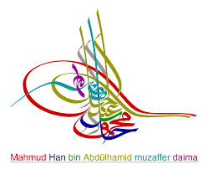
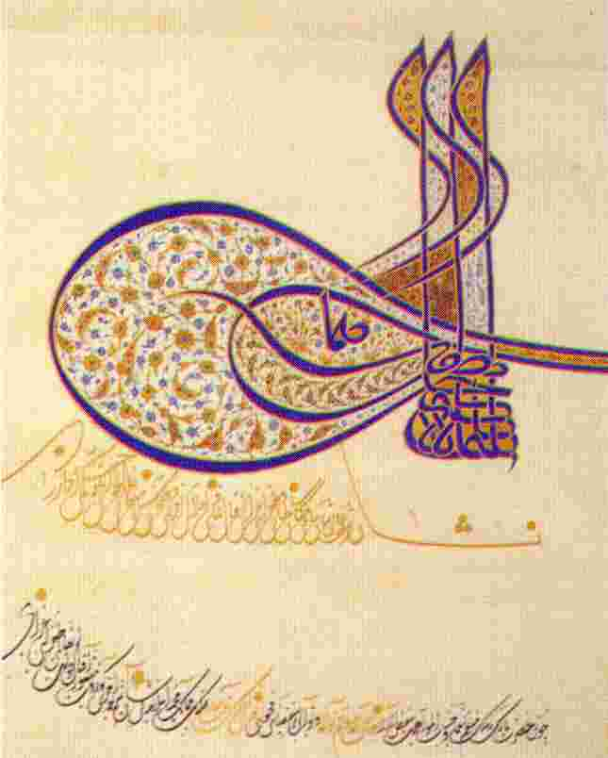
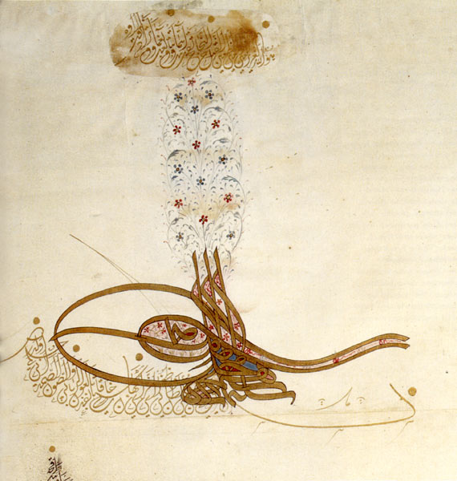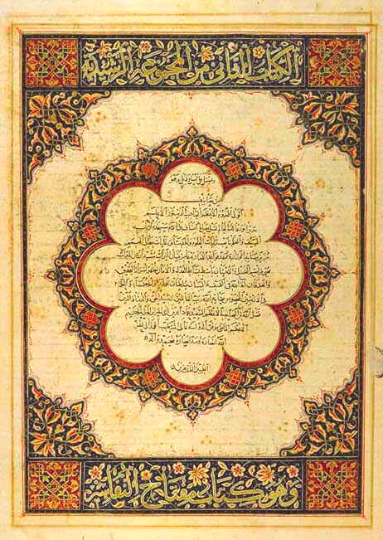

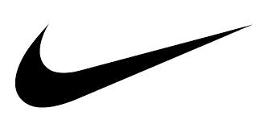

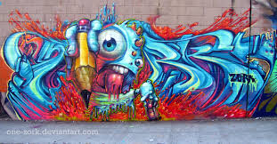
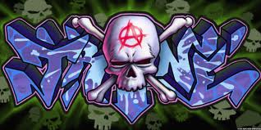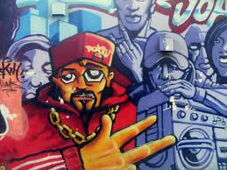
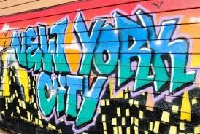

Istanbul (Not Constantinople) - Lyrics Sheet
-Artists: The Four Lads
-peak Billboard position # 10 in 1953
-Words by Jimmy Kennedy and Music by Nat Simon
Istanbul was Constantinople
Now it's Istanbul not Constantinople
Been a long time gone
Old Constantinople's still has Turkish delight
On a moonlight night
Evr'y gal in Constantinople
Is a Miss-stanbul, not Constantinople
So if you've date in Constantinople
She'll be waiting in Istanbul
Even old New York was once New Amsterdam
Why they changed it, I can't say
(People just liked it better that way)
Take me back to Constantinople
No, you can't go back to Constantinople
Now it's Istanbul, not Constantinople
Why did Constantinople get the works?
That's nobody's business but the Turks'
Istanbul!!
Istanbul!!
Even old New York was once New Amsterdam
Why they changed it, I can't say
(People just liked it better that way)
Take me back to Constantinople
No, you can't go back to Constantinople
Now it's Istanbul, not Constantinople
Why did Constantinople get the works?
That's nobody's business but the Turks'
Istanbul!!

