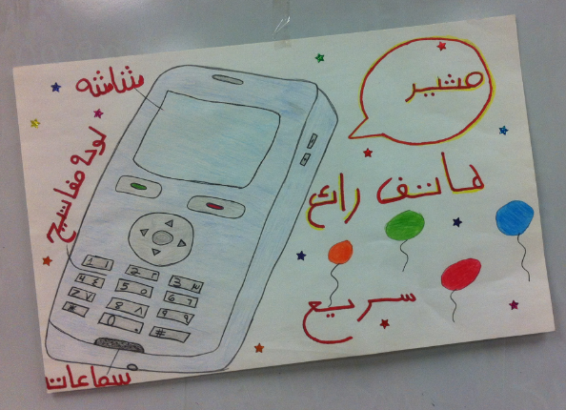
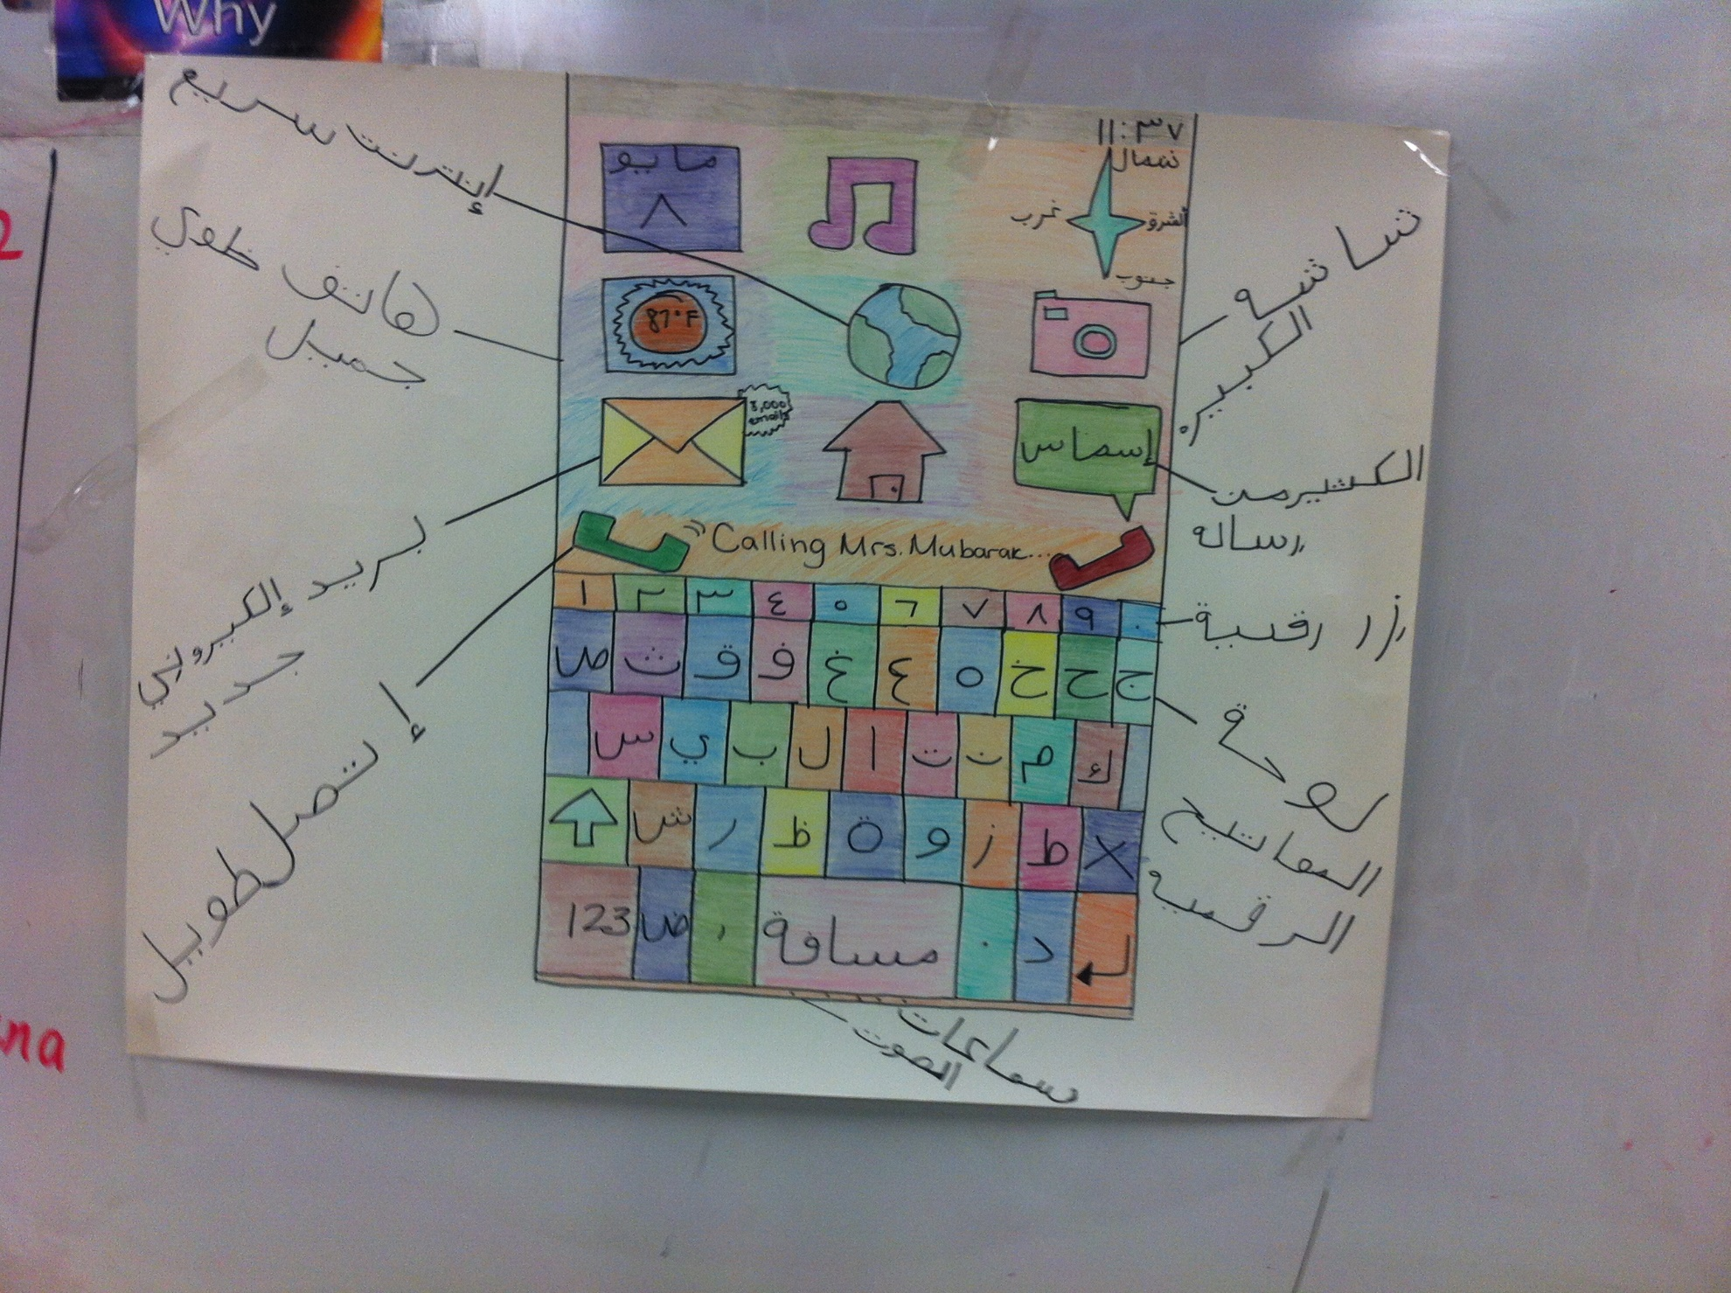
Teacher Name: Nema Mubarak School Name: White Haven High School
Unit Name: Using Modern Technology ( My Cellular Device) Subject: Arabic III&IV Grades:11-12
Standards:
List of the State/District standards addressed in the lesson.
National & TN Standard 1.1
1.1L Give simple descriptions, 1.1N Ask simple questions and provide responses based on general topic.
National & TN Standard 1.2
1.2A Identify the main ideas and some details when reading and listening.
National & TN Standard 1.3
1.3A Give short informal presentation spoken or written on a familiar topic.
21st Century Skills
Communication, Collaboration, Critical thinking, Creativity, and Social & Cross Cultural Skills.
District standards for Foreign Language Learning
Communication:
Students communicate these words and terms in all four phases, listening, speaking, reading and writing
Culture:
Students understand the cultural contents and back ground of these words and terms
Comparisons:
Students can compare how these terms can interact in both Arabic and English languages
Connections and Communities
The Standards relate to the lesson:
- Interpretive communication (Standard 1.2), which has to do with demonstrating comprehension of content from authentic audio and visual resources
- Cultures: practice and products (Standard 2.1 and 2.2), which has to do with examining, comparing, and reflecting on products and /or perspectives of the target culture
- Connections (Standard 3.2), which has to do with acquiring information from other content areas using authentic sources
- Comparisons: language (Standard 4.1), which has to do with evaluating similarities and differences in language

Essential Questions:
- How science is used to improve the world?
- What students will benefits from using modern telecommunication technologies in Arabic language?
- How use the language both within and beyond school?
- How does the world become more accesible?
Objectives:
In addressing the topic of using technology in our daily life, students will provide and obtain information, understand spoken and written language, present information to their classmates, describing their favorite device.

- Students will be familiar with some Arabic words and terms commonly used in Internet and other electronics devices. student will be able to pronounce correctly, spell, read and write these words. Students will be able to communicate and interpret the meaning of these words and terms.
- Students will be able to recognize and use these words and terms in practical setting, like talking in Arabic language about their phones and important issues of technology in their daily life.
- The students will relate ideas and information to life experiences.

- The students will use a variety of resources such as technology to access, analyze, interpret, synthesize, apply and communicate information.

Materials:
Projectors -Power point- Computers-Audio CDs-Videos-Arab World Map.

Activities:
- Students will develop an understanding of the issue of using technology in daily life. Also, they will discuss the positive traits of using their phones on a daily basis. The entire class will discuss and share their answers, furthermore, students will continue to develop their language skills.
- Since this is a unit on using technology, have students brainstorm a list of questions pertaining to the people reaction toward the new cell phones. Also, they would like to ask of their counterparts in another Arab country about their devices.
- Students are allowed to E-mail the questions. Student may choose to send those questions to students in different cities in different locations in the target countries.
- Students collect the responses to the following questions, “How do the Arabs communicate with each other in their community?” “What I should do to get a cell phone in your country?” and “what is the general reaction when new technologies such as smart phones are release it in the target country?”
- Students read and share their answers with the rest of the class and begin to organize the answers into topics.
- In groups, students select from a list of specified questions. Students begin researching and collecting information on their selected topic by using online searches.
- Students organize their research and develop a presentation to be made to their classmates by doing one the following tasks: create a videotape, present orally to an audience, create a descriptive poster in order to advertise their cell phone to their classmates.
Closure:
Each group presents its work orally, written, creating and designing an advertisement.
This lesson culminates with a group question and answer session of the importance of using the new devices in everyone life.
the expectation and the final task is students must write a short paragraph which explains what various people opinions of the need and the importance of electronic devices in our daily lives also discuss the negative effects of these modern tools on the young people lives and behavior

Assessments:
Presentational:
- Speaking: students present orally to an audience
- Writing: create a description poster
Interpretative:
Students demonstrate understanding by actively participating in class discussion.

Task Instructions( for the student work sample):
- Brain- Storming
- Pre-Writing
- Working with a partner, list five things, try to come up with five very different things, students share their things with class.
- Debate
- Group Discussion
- Make Inferences
- Summarize
- Background Knowledge
- Internet/Online Resources
- Make Inferences

